Awards and Recognitions Received for Extension Activities from Government and Government Recognised Bodies

Sl No: | Name of Award | Year of Award | Awarding Body | Page No.
1 | Certificate of Appreciation from Tribal Extension Officer, Edamalayar | 2024 | Office of the Tribal Extension Officer, Government of Kerala, Edamalayar
2 | Certificate of Appreciation from Chief Executive Officer, Malayattoor Forest Department | 2024 | Office of the Chief Executive Officer, Forest Department, Government of Kerala, Malayattoor
3 | Certificate of Appreciation from Scheduled Tribes Development Department, Edamalayar | 2024 | Office of the Tribal Extension Officer, Government of Kerala, Edamalayar
4 | Certificate of Appreciation from the Government UP School, Edamalayar | 2024 | Government UP School, Edamalayar - 686681
5 | Letter of Appreciation from Superintendent, Govt. Ayurveda College Hospital | 2024 | Superintendent, Govt. Ayurveda College Hospital, Thripunithura
6 | Letter of Appreciation from Member of Kerala Legislative Assembly, Thrikkakara | 2024 | Uma Thomas MLA, Thrikkakara, Cochin 682025
7 | Letter of Appreciation from Mar Coorilose Memorial Higher Secondary School, Pattimattom | 2024 | Principal, Mar Coorilose Memorial Higher Secondary School, Pattimattom,683562
8 | Letter of Appreciation from Snehajyothy Sisubhavan | 2024 | Snehajyothy Sisubhavan, Pulluvazhi P.O, Perumbavoor 683541
9 | Letter of Appreciation from K.M.L.P.S, Eroor | 2024 | K.M.L.P School, Eroor 682036
10 | Certificate of Appreciation from Divisional Forest Officer, Malayattoor Forest Department | 2024 | Office of the Divisional Forest Officer, Forest Department, Malayattoor
11 | Letter of Appreciation from St. Mary’s Higher Secondary School | 2024 | St. Mary’s Higher Secondary School, Thalacode P.O, Mulanthuruthy 682314
12 | Letter of Appreciation from Kochi Municipal Corporation | 2024 | Councillor, Kochi Municipal Corporation, Division 42.
13 | Certificate of Appreciation from Government Children’s Home | 2024 | Government Children’s Home, Ernakulam 682030
14 | Certificate of Appreciation from Indian Postal Service | 2024 | Sub Postmaster, Indian Postal Service, Rajagiri Valley 682039
15 | Letter of Appreciation from Thalir Kudumbasree | 2023 | President, Thalir Kudumbasree, NHG 43, Elamakkara
16 | Letter of Appreciation from Sevagram | 2023 | Sevagram, Avedana Bhavan, Pothi 686605
17 | Letter of Appreciation from Valsalyam (Sisubhavan) | 2023 | Valsalyam(Sisubhavan), Kalamassery 683503
18 | Letter of Appreciation from SVLP School | 2023 | SVLP School, Thripunitura,682301
19 | Letter of Appreciation from Karunalayam, Home for the Aged Destitute & Mentally Challenged Women | 2023 | Karunalayam, Home for the Aged Destitute & Mentally Challenged Women, Thrikkakara 682021
20 | Certificate of Appreciation from Thrikkakara Municipality | 2023 | Councillor, Thrikkakara Municipality, Kakkanad, Kochi 682030
21 | Certificate of Appreciation from, Thiruvaniyoor Grama Panchayat | 2023 | Thiruvaniyoor Grama Panchayat, Mamala PO, Ernakulam 682305
22 | Certificate of Appreciation from the District Collector, Ernakulam | 2023 | District Collector, Ernakulam
23 | Certificate of Appreciation from KSRTC | 2023 | Kerala State Transport Corporation (KSRTC), Aluva
24 | Letter of Appreciation from Sevagram | 2023 | Sevagram, Pothy, Thalayolaparambu 686605
25 | Certificate of Appreciation from Indian Postal Service | 2023 | Indian Postal Service, Rajagiri Valley 682039
26 | Letter of Appreciation from Home of Faith, Charitable Society | 2023 | Home of Faith, Charitable Society, Chittethukara 682037
27 | Certificate of Appreciation from Motor Vehicle Department (MVD) | 2023 | Motor Vehicle Department (MVD), Regional Transport Office (RTO), Ernakulam
28 | Certificate of Appreciation from Health Department | 2023 | Health Standing Committee Chairman, Division 14, Cochin
29 | Letter of Appreciation from St. Mary’s Higher Secondary School | 2023 | St. Mary’s Higher Secondary School, Mulanthuruthy
30 | Certificate of Appreciation from Government Children’s Home | 2023 | Government Children’s Home, Ernakulam 682030
31 | Letter of Appreciation from Lower Primary School | 2023 | Lower Primary School,Irumpanam Post, Ernakulam 682309
32 | Certificate of Appreciation from Kunji Store, IEDC | 2023 | Kunji Store, IEDC
33 | Certificate of Appreciation from Popkon Creatives | 2023 | Popkon Creatives, Cochin
34 | Award from State NSS Officer, Government of Kerala | 2022 | State NSS Office, Government of Kerala, Trivandrum
35 | Letter of Appreciation from Aided Lower Primary School | 2022 | Aided Lower Primary School, Mulvukad 682504
36 | Letter of Appreciation from St. Mary’s Higher Secondary School | 2022 | St. Mary’s Higher Secondary School, Mulanthuruthy
37 | Letter of Appreciation from Assisi Snehalaya Charitable Trust | 2022 | Assisi Snehalaya Charitable Trust, Coimbatore 641105
38 | Letter of Appreciation from Parama Bhattara Kendriya Vidyalayam | 2022 | Principal, Parama Bhattara Kendriya Vidyalayam, Ernakulam 682038
39 | Letter of Appreciation from D.V.U.P. School | 2020 | D.V.U.P School, Nayarambalam 682509
40 | Letter of Appreciation from St. Mary’s Higher Secondary School | 2019 | St. Mary’s Higher Secondary School, Mulanthuruthy
41 | Letter of Appreciation from Ernakulam District Administration | 2019 | District Collector, Ernakulam District, Government of Kerala

- Certificate of Appreciation from Tribal Extension Officer, Edamalayar

Name of Award | Certificate of Appreciation from Tribal Extension Officer, Edamalayar
Nature of Activity | Outreach activity of NSS to Govt. U.P School, Edamalayar
Awarding Body | Office of the Tribal Extension Officer, Government of Kerala, Edamalayar
Year of Award | 2024
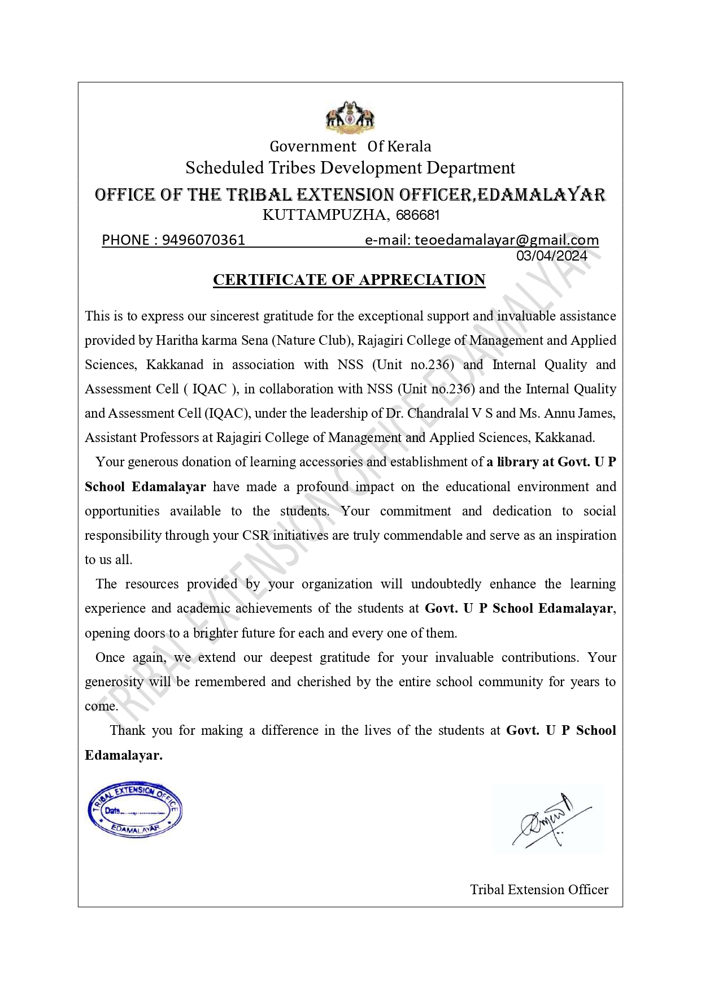
Certificate of Appreciation

- Certificate of Appreciation from Chief Executive Officer, Malayattoor Forest Department

Name of Award | Certificate of Appreciation from Chief Executive Officer, Malayattoor Forest Department
Nature of Activity | Outreach activity of NSS to Community
Awarding Body | Office of the Chief Executive Officer, Forest Department, Government of Kerala, Malayattoor
Year of Award | 2024

Certificate of Appreciation
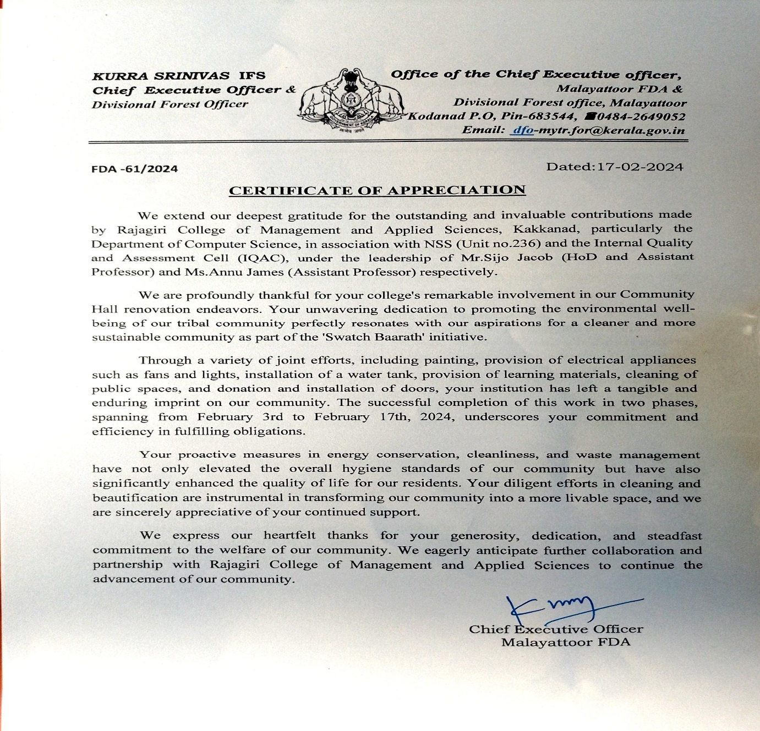

- Certificate of Appreciation from Tribal Extension Officer, Edamalayar

Name of Award | Certificate of Appreciation from Scheduled Tribes Development Department, Edamalayar
Nature of Activity | Outreach activity of NSS to Tribal Colony Community
Awarding Body | Office of the Tribal Extension Officer, Government of Kerala, Edamalayar
Year of Award | 2024

Certificate of Appreciation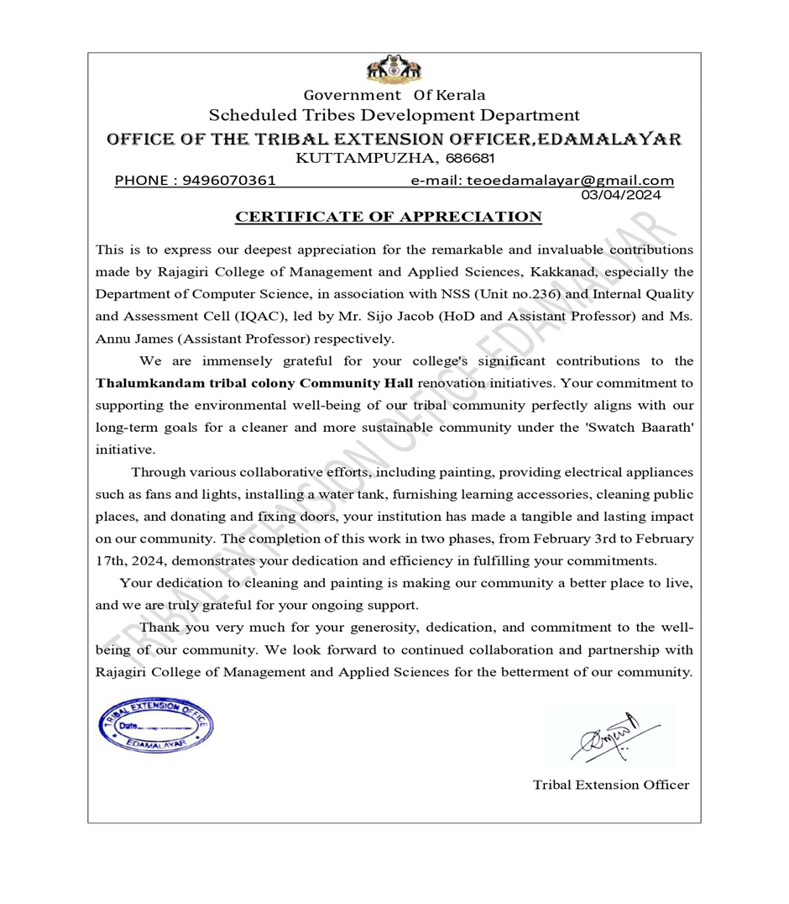

- Certificate of Appreciation from the Government UP School, Edamalayar

Name of Award | Certificate of Appreciation from the Government UP School, Edamalayar
Nature of Activity | Outreach activity of NSS to Govt. U P School
Awarding Body | Government UP School, Edamalayar - 686681
Year of Award | 2024

Certificate of Appreciation
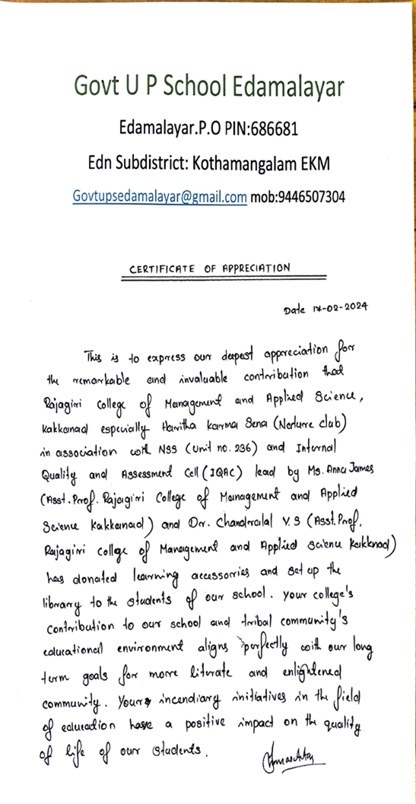
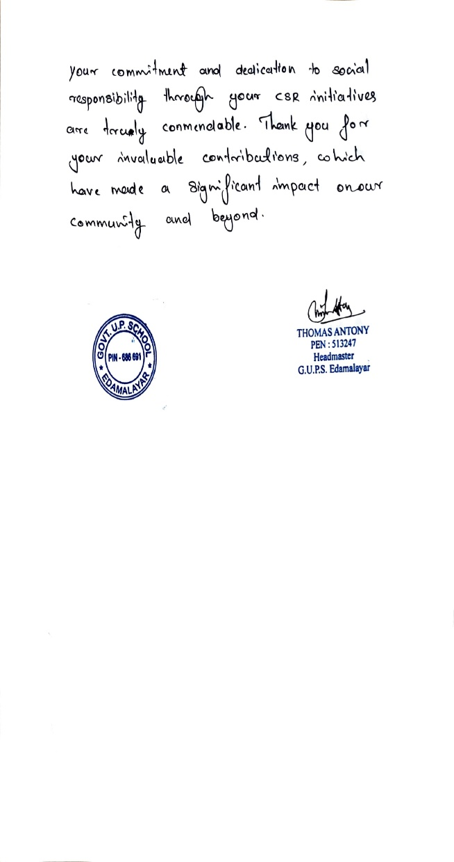

- Letter of Appreciation from Member of Kerala Legislative Assembly, Thrikkakara

Name of Award | Letter of Appreciation from Govt. Ayurveda College Hospital
Nature of Activity | Outreach activity of NSS to Govt. U P School
Awarding Body | Superintendent, Govt. Ayurveda College Hospital, Thripunithura
Year of Award | 2024

Letter of Appreciation
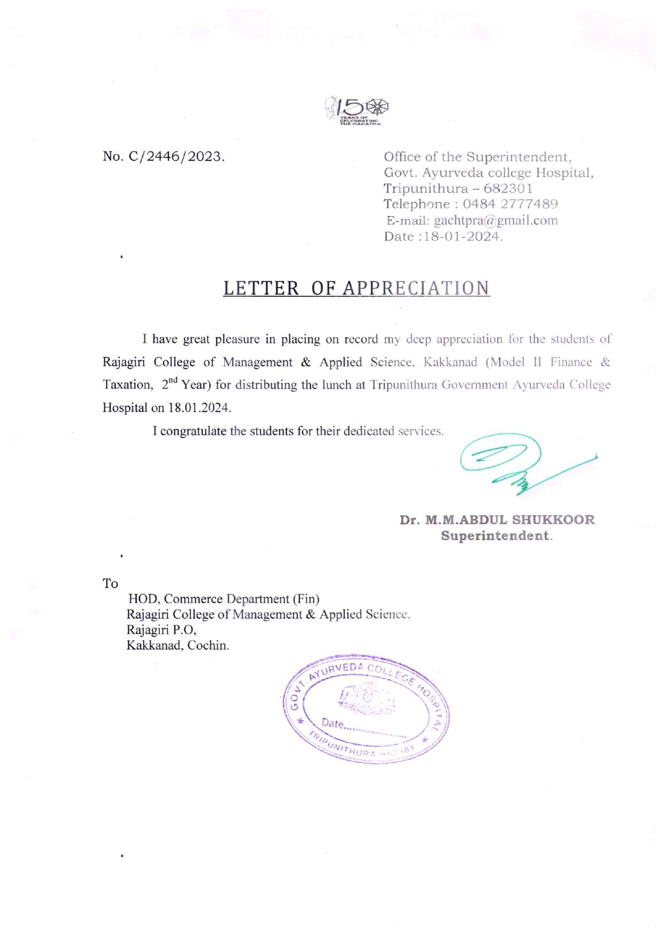

- Letter of Appreciation from Member of Kerala Legislative Assembly, Thrikkakara

Name of Award | Letter of Appreciation from Member of Kerala Legislative Assembly, Thrikkakara
Nature of Activity | Extension activity through NSS to Community
Awarding Body | Uma Thomas MLA, Government of Kerala
Year of Award | 2024

Letter of Appreciation

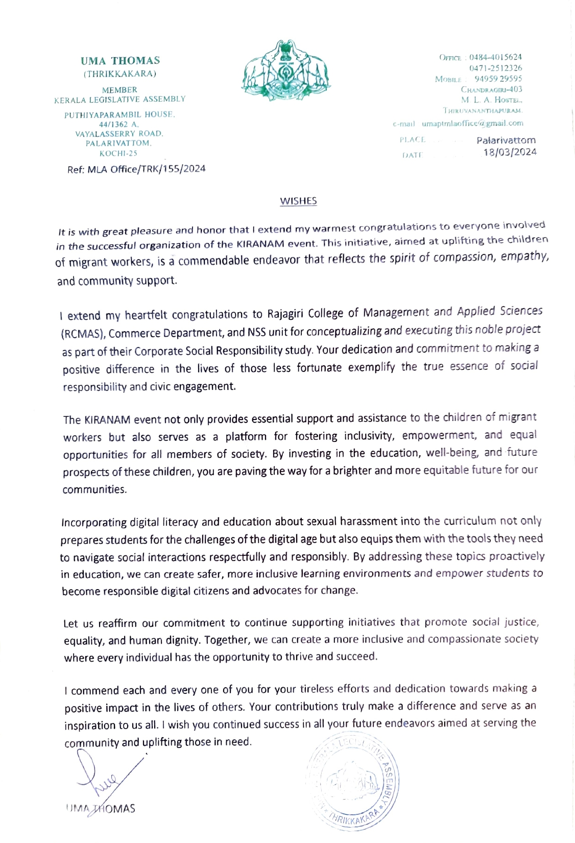

- Letter of Appreciation from Mar Coorilose Memorial Higher Secondary School, Pattimattom

Name of Award | Letter of Appreciation from Mar Coorilose Memorial Higher Secondary School, Pattimattom
Nature of Activity | Extension activity through NSS to Community
Awarding Body | Principal, Mar Coorilose Memorial Higher Secondary School, Pattimattom,683562
Year of Award | 2024

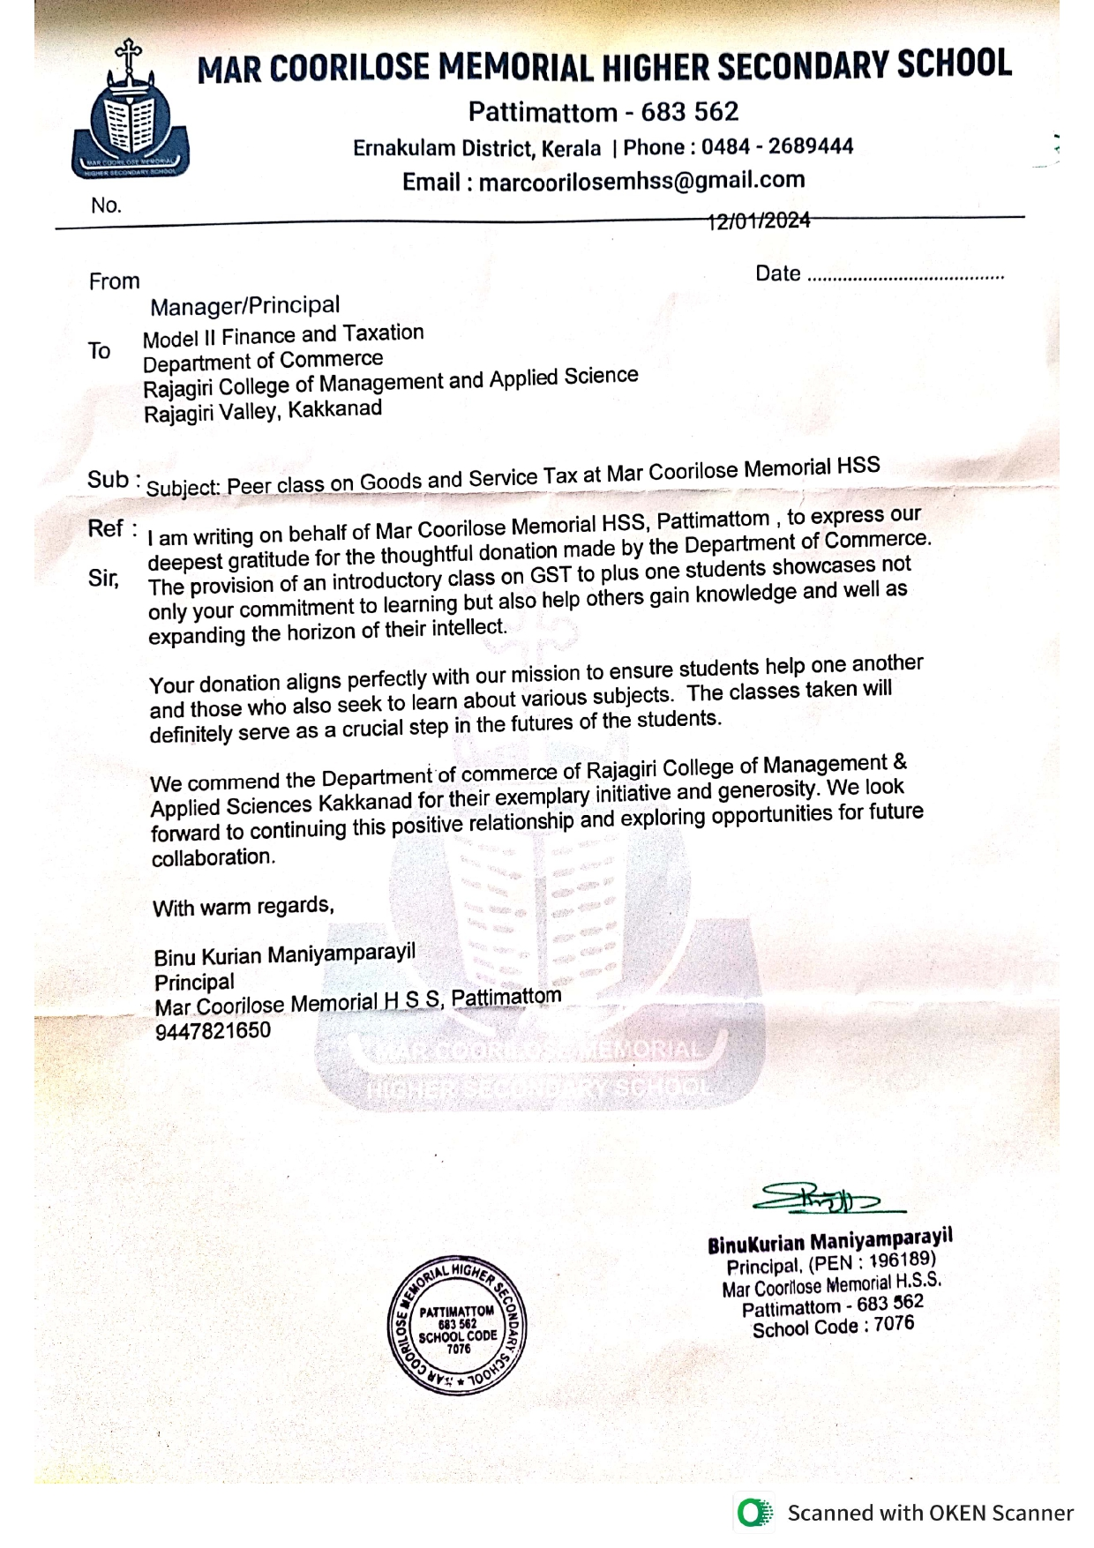
Letter of Appreciation

- Letter of Appreciation from Snehajyothy Sisubhavan

Name of Award | Letter of Appreciation from Snehajyothy Sisubhavan
Nature of Activity | Outreach activity of NSS
Awarding Body | Snehajyothy Sisubhavan, Pulluvazhi P.O, Perumbavoor 683541
Year of Award | 2024

Letter of Appreciation

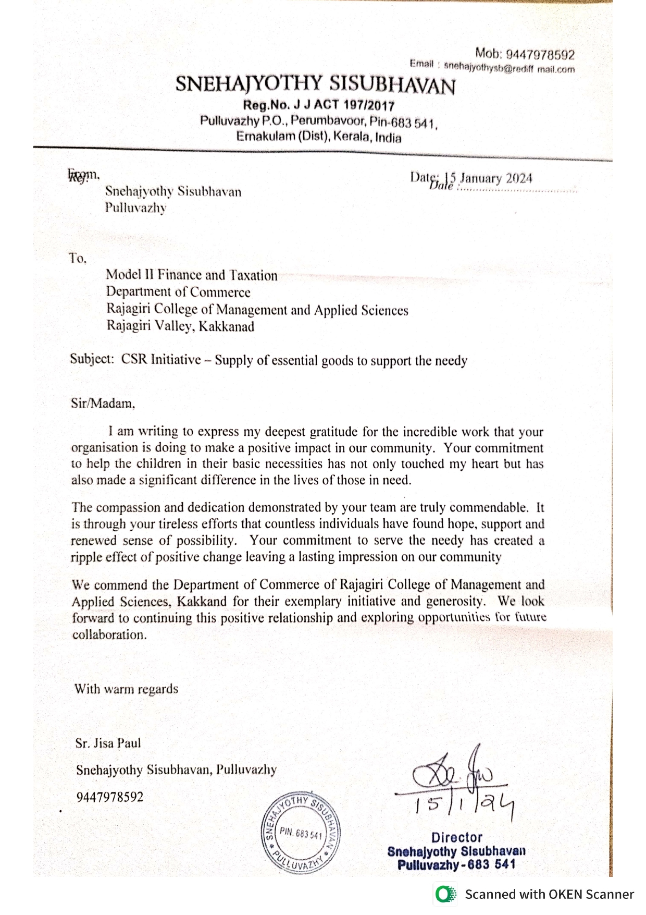

- Letter of Appreciation from K.M.L.P.S, Eroor

Name of Award | Letter of Appreciation from K.M.L.P.S, Eroor
Nature of Activity | Extension activity through NSS to Community
Awarding Body | K.M.L.P School, Eroor 682036
Year of Award | 2024

Letter of Appreciation

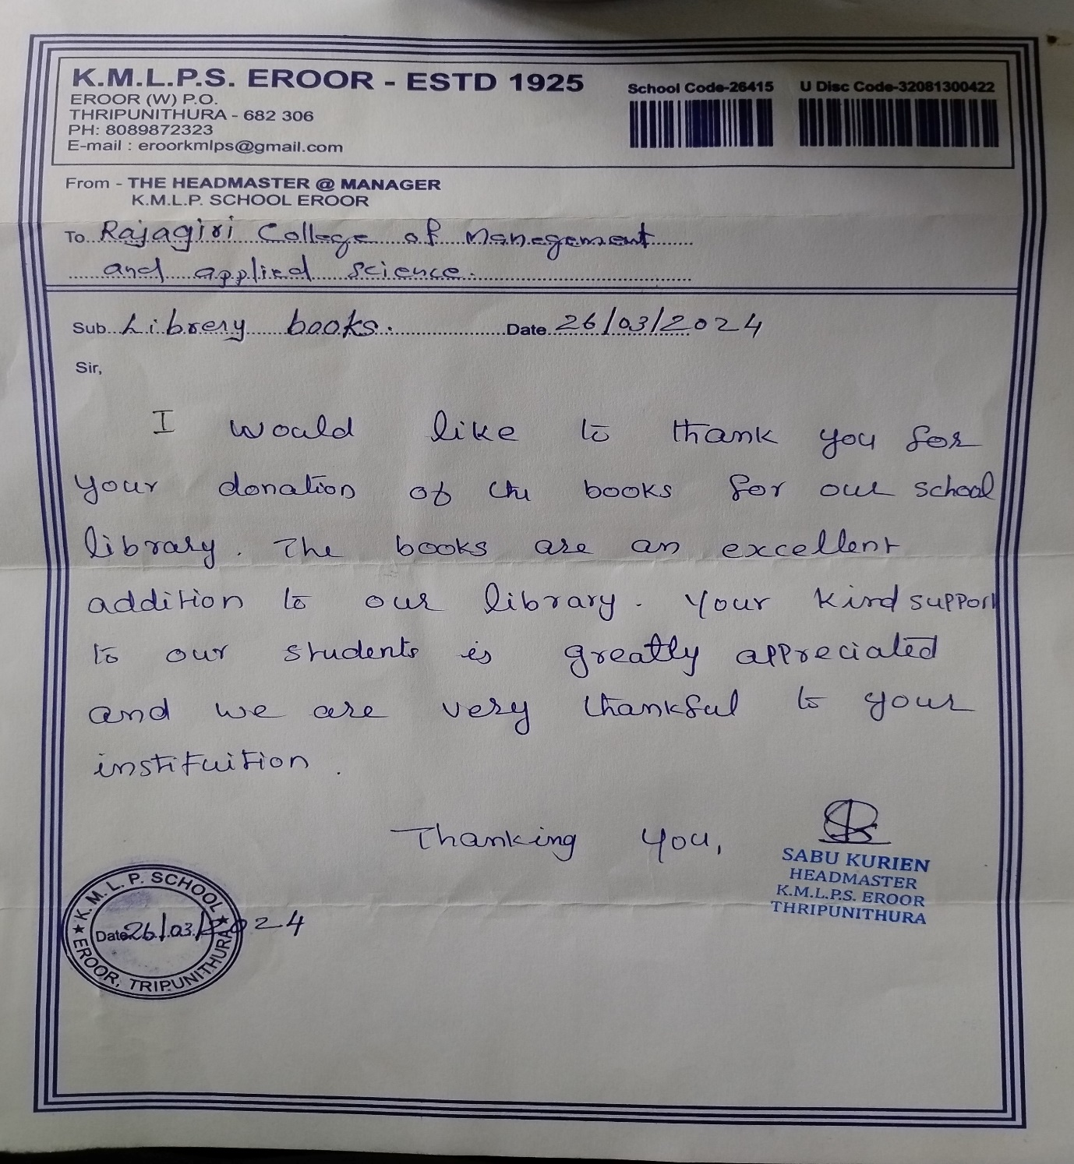

- Certificate of Appreciation from Divisional Forest Officer, Malayattoor Forest Department

Name of Award | Certificate of Appreciation from Divisional Forest Officer, Malayattoor Forest Department
Nature of Activity | Outreach activity through NSS to Community
Awarding Body | Office of the Divisional Forest Officer, Forest Department, Malayattoor, Government of Kerala
Year of Award | 2024

Certificate of Appreciation
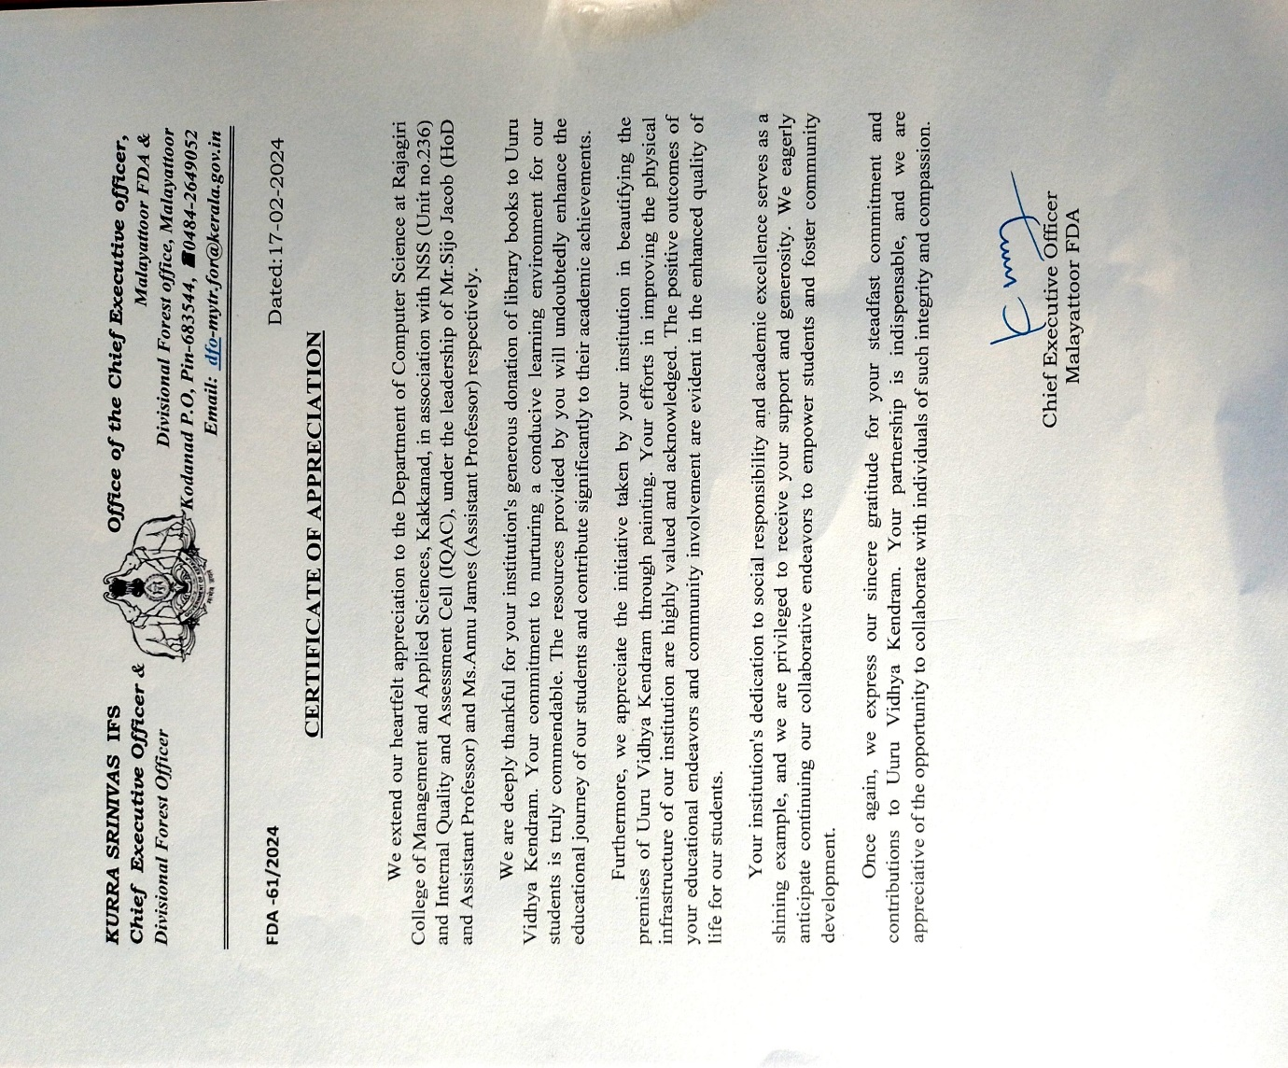

- Letter of Appreciation from St. Mary’s Higher Secondary School

Name of Award | Letter of Appreciation from St. Mary’s Higher Secondary School
Nature of Activity | Extension activity through NSS
Awarding Body | St. Mary’s Higher Secondary School, Thalacode P.O, Mulanthuruthy 682314
Year of Award | 2024

Letter of Appreciation

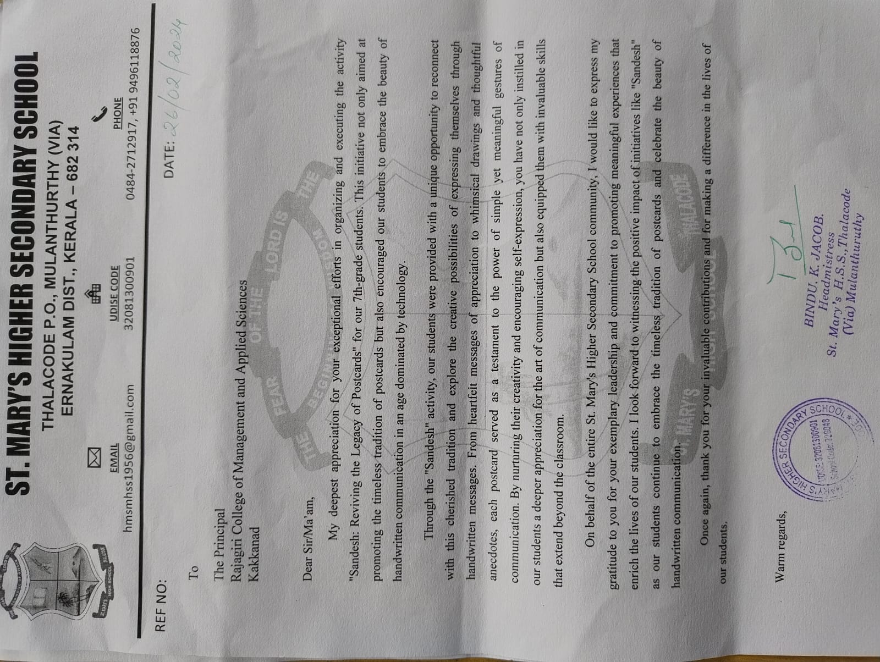

- Letter of Appreciation from Kochi Municipal Corporation

Name of Award | Letter of Appreciation from Kochi Municipal Corporation.
Nature of Activity | Outreach activity through NSS to Community
Awarding Body | Councillor, Kochi Municipal Corporation, Division 42
Year of Award | 2024

Letter of Appreciation

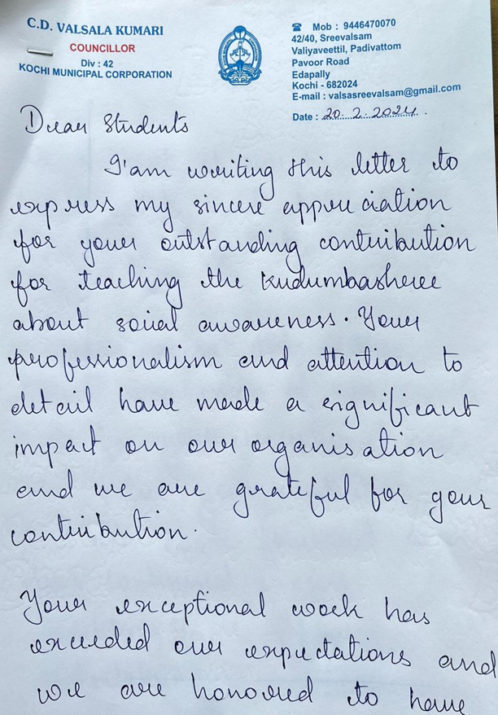

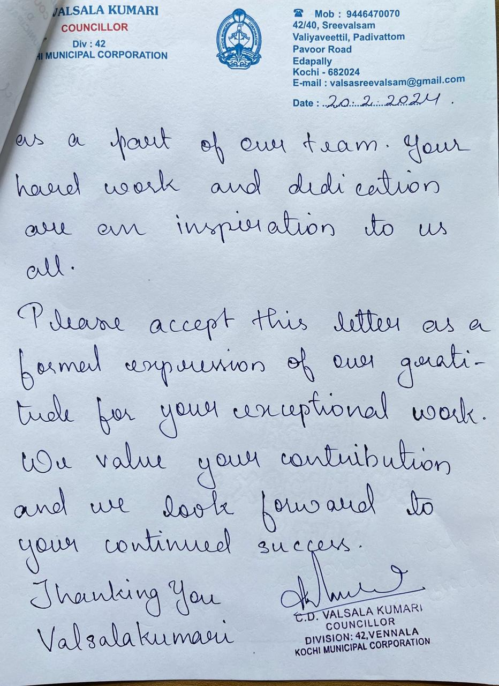

- Certificate of Appreciation from Government Children’s Home

Name of Award | Certificate of Appreciation from Government Children’s Home
Nature of Activity | Outreach activity through NSS to Community
Awarding Body | Government Children’s Home, Ernakulam 682030
Year of Award | 2024

Certificate of Appreciation 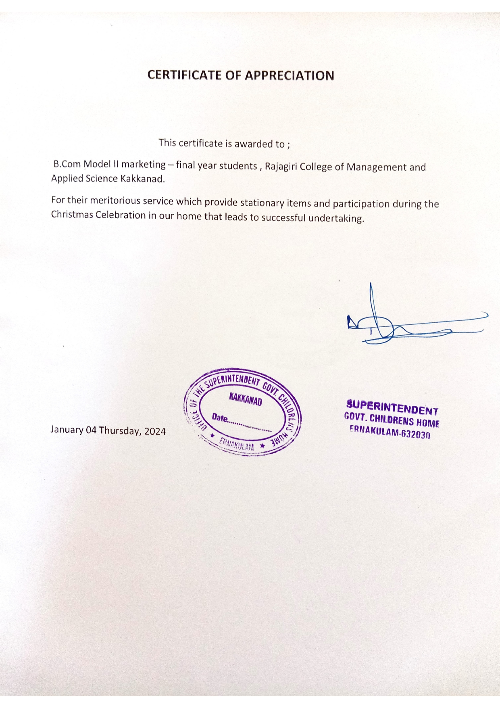

- Certificate of Appreciation from Indian Postal Service
Name of Award | Certificate of Appreciation from Indian Postal Service
Nature of Activity | Extension activity through NSS to Community
Awarding Body | Indian Postal Service, Rajagiri Valley 682039
Year of Award | 2024

Certificate of Appreciation

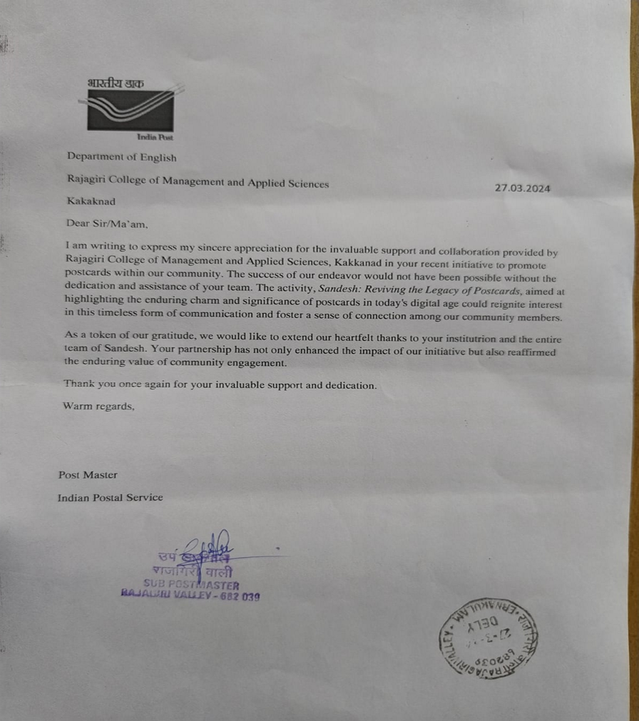

- Letter of Appreciation from Thalir Kudumbasree
Name of Award | Letter of Appreciation from Thalir Kudumbasree
Nature of Activity | Outreach activity through NSS to Community
Awarding Body | President, Thalir Kudumbasree, NHG 43, Elamakkara
Year of Award | 2023

Letter of Appreciation
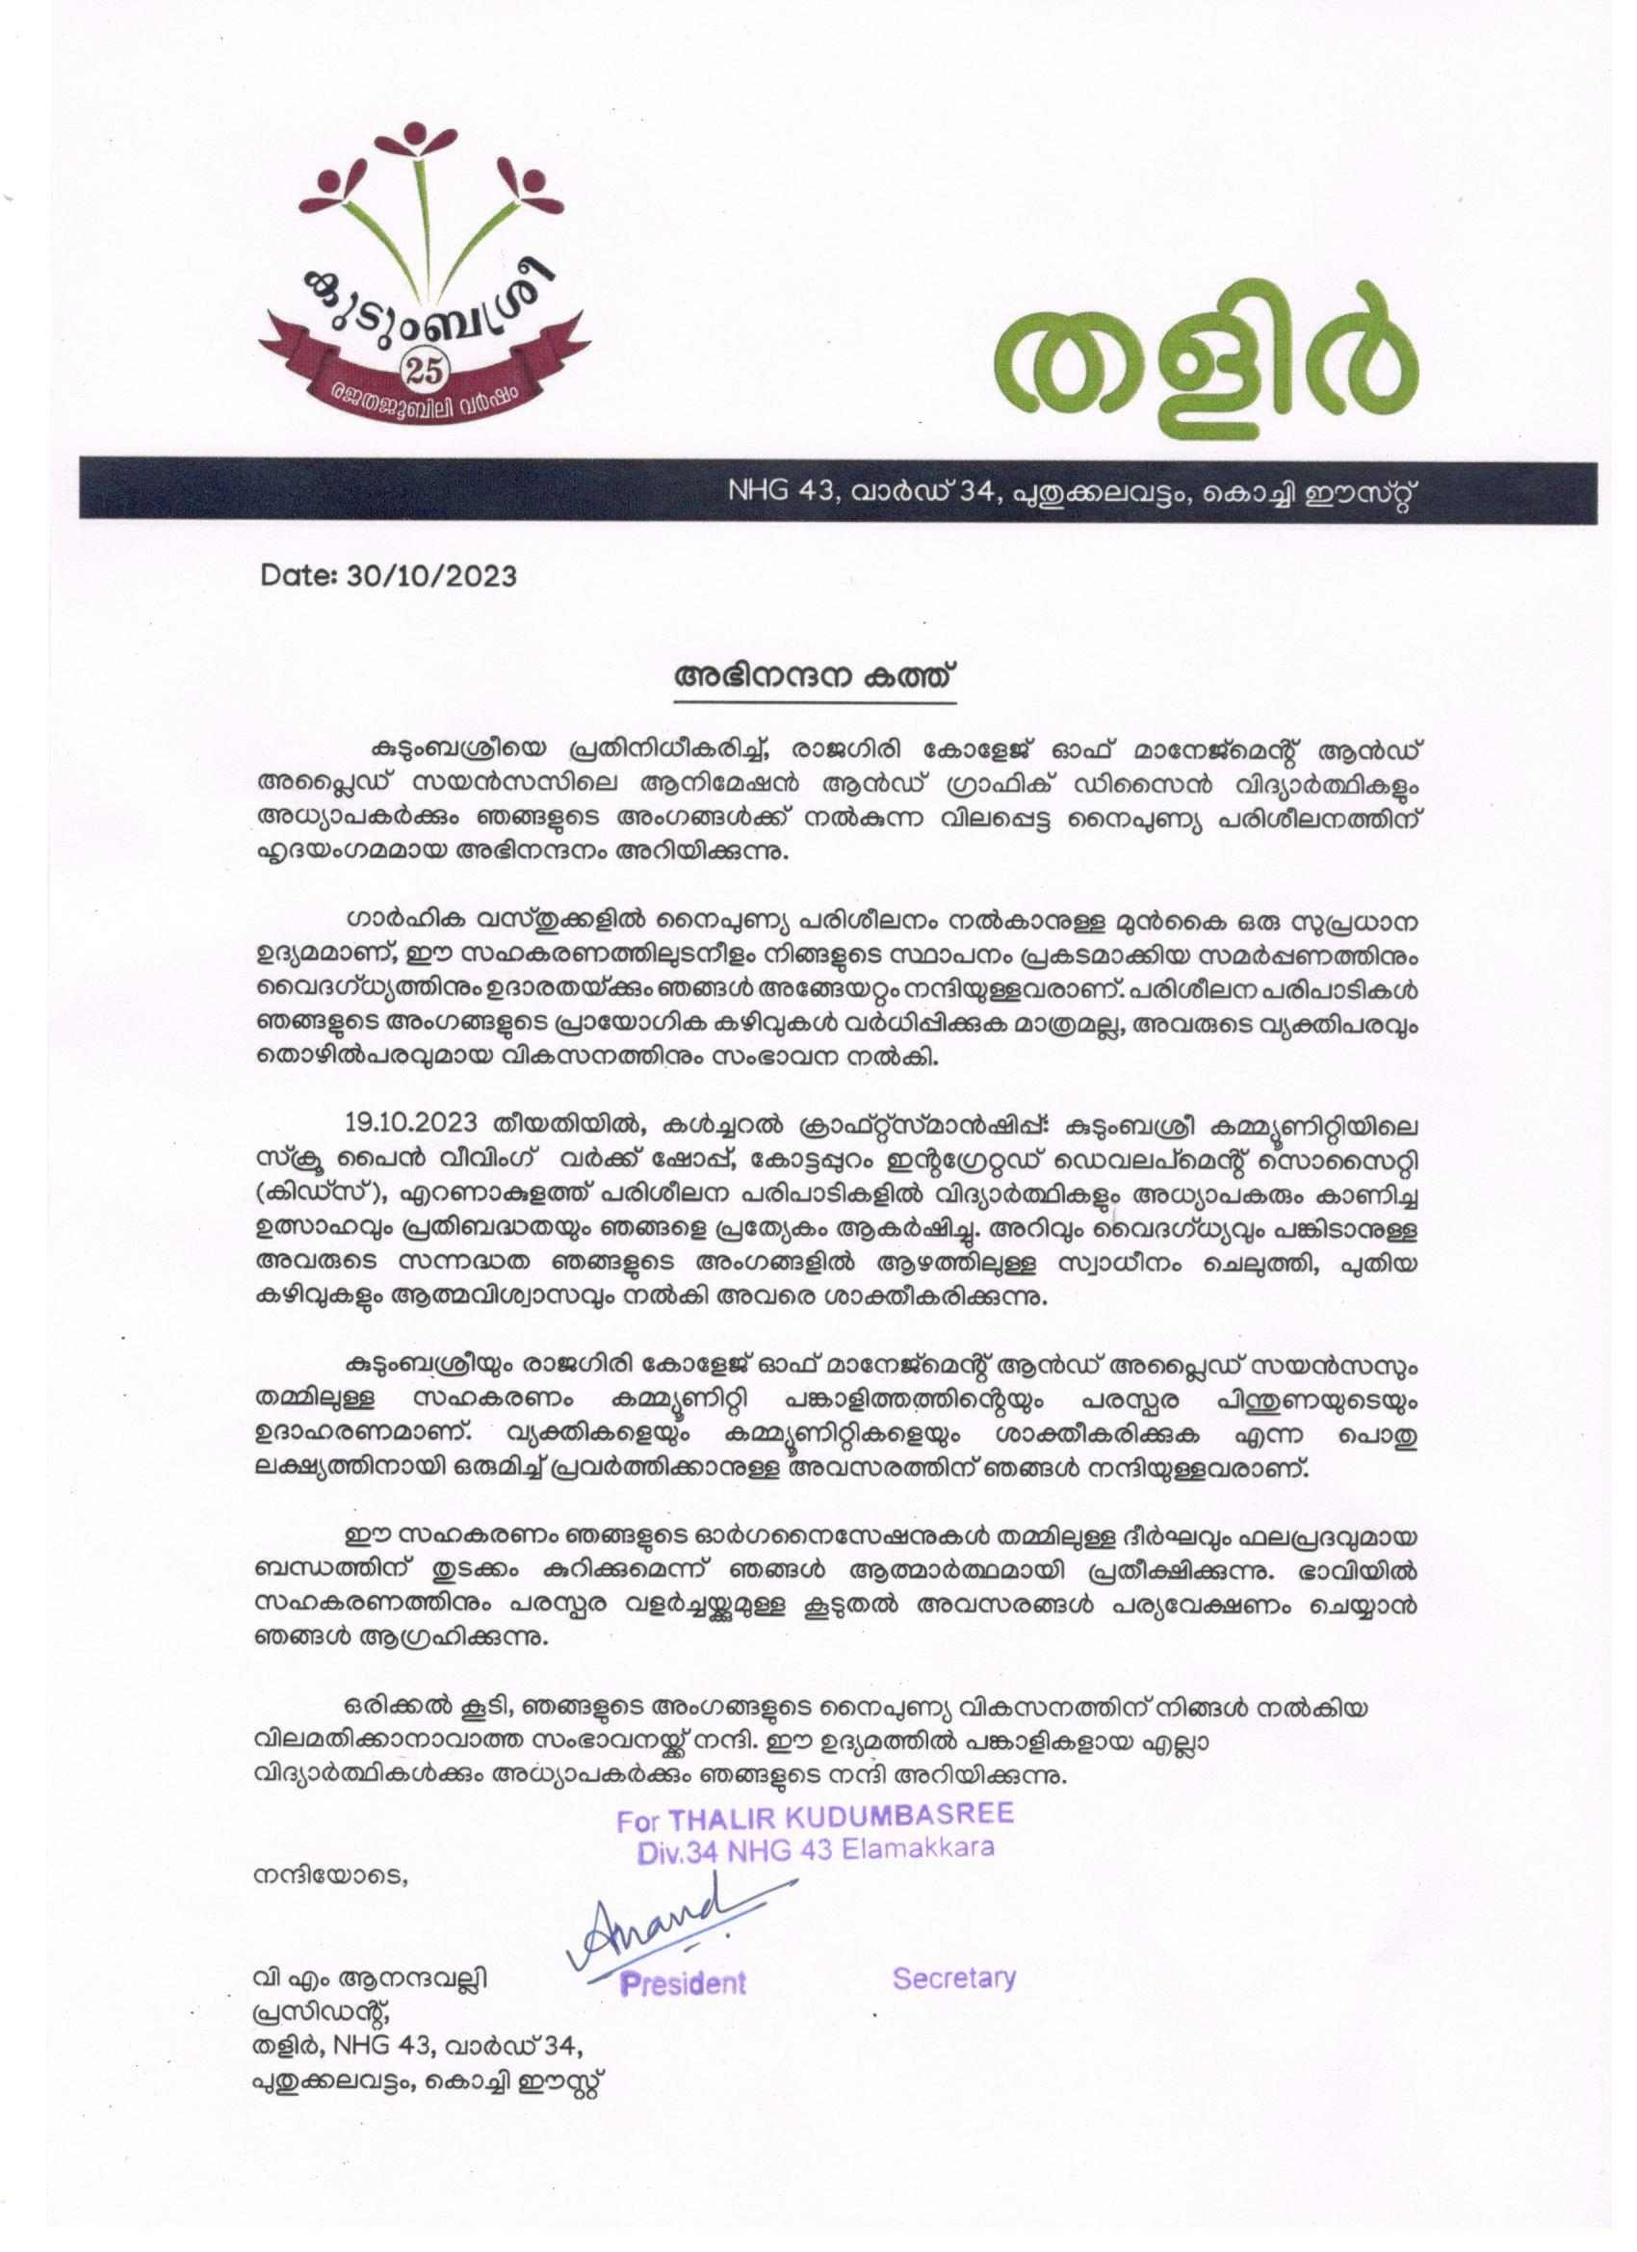

- Letter of Appreciation from Sevagram
Name of Award | Letter of Appreciation from Sevagram
Nature of Activity | Outreach activity through NSS to Community
Awarding Body | Sevagram, Avedana Bhavan, Pothi 686605
Year of Award | 2023

Letter of Appreciation

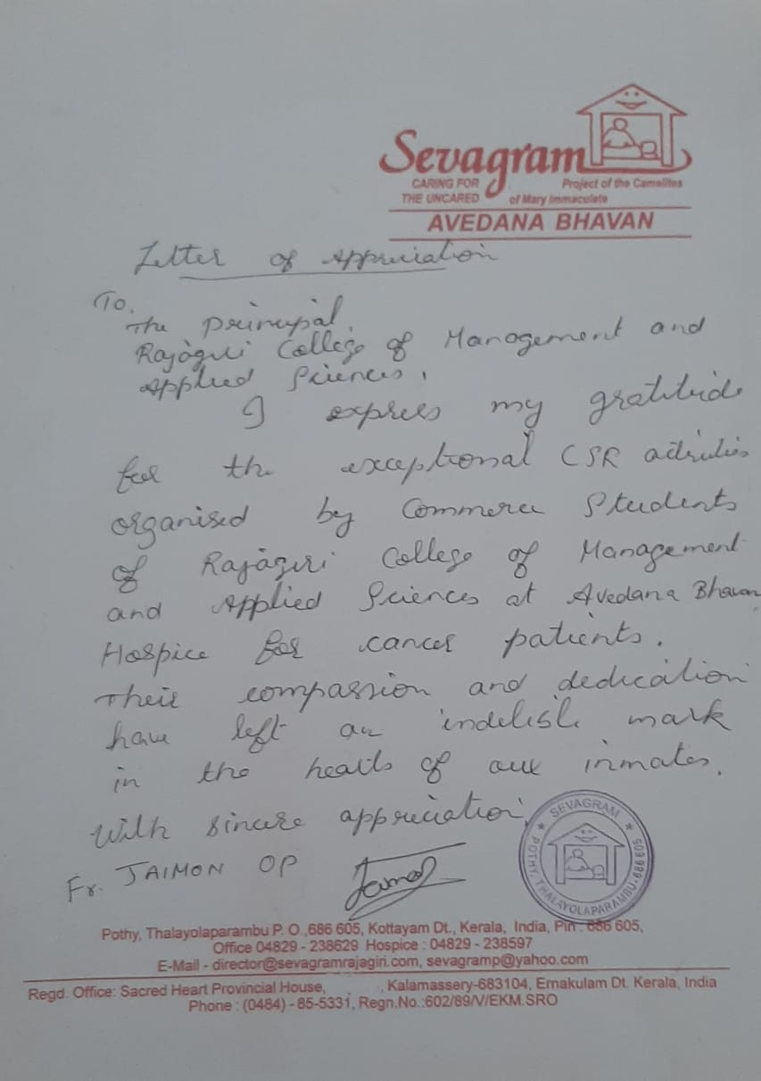

- Letter of Appreciation from Valsalyam (Sisubhavan)

Name of Award | Letter of Appreciation from Valsalyam (Sisubhavan)
Nature of Activity | Outreach activity through NSS to Community
Awarding Body | Valsalyam(Sisubhavan), Kalamassery 683503
Year of Award | 2023

Letter of Appreciation
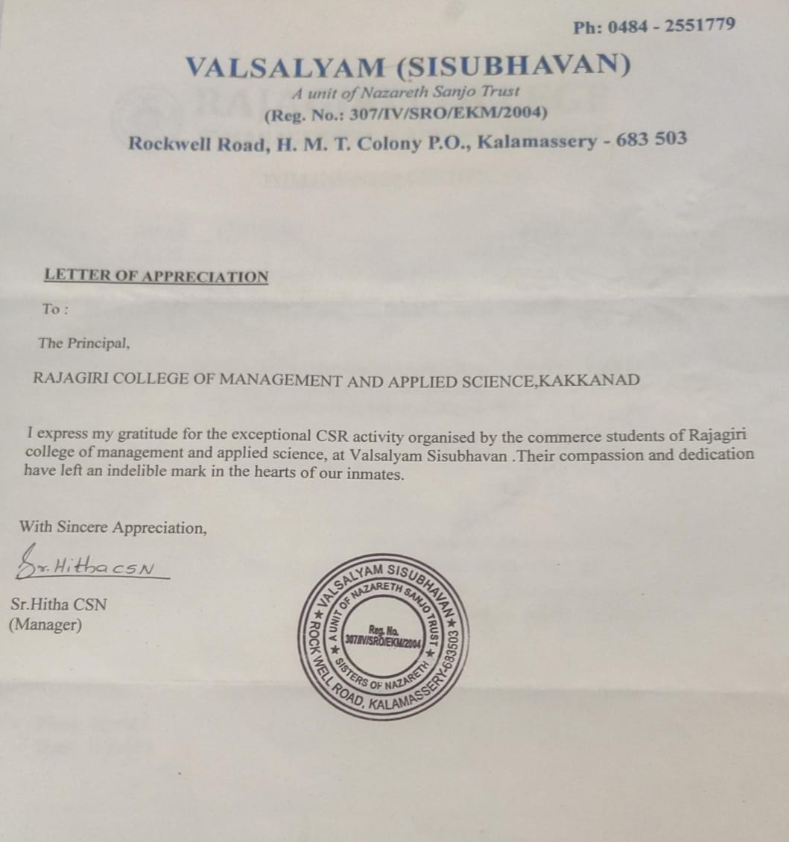

- Letter of Appreciation from SVLP School
Name of Award | Letter of Appreciation from SVLP School
Nature of Activity | Extension activity through NSS to Community
Awarding Body | SVLP School, Thripunitura,682301
Year of Award | 2023

Letter of Appreciation

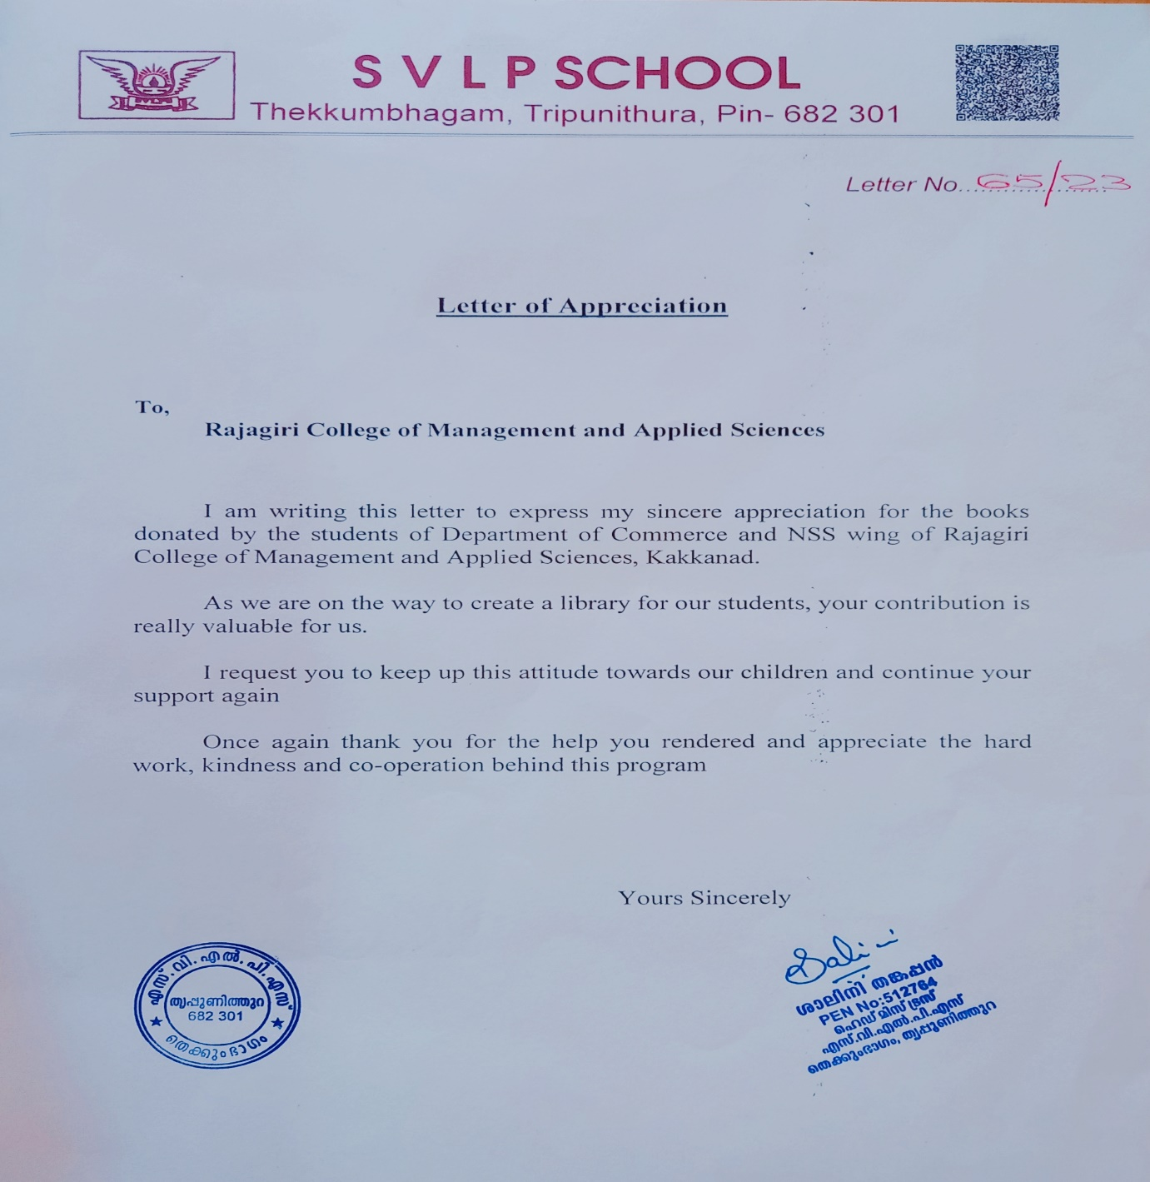

- Letter of Appreciation from Karunalayam, Home for the Aged Destitute & Mentally Challenged Women

Name of Award | Letter of Appreciation from Karunalayam, Home for the Aged Destitute & Mentally Challenged Women
Nature of Activity | Outreach activity through NSS to Community
Awarding Body | Karunalayam, Home for the Aged Destitute & Mentally Challenged Women, Thrikkakara 682021
Year of Award | 2023

Letter of Appreciation

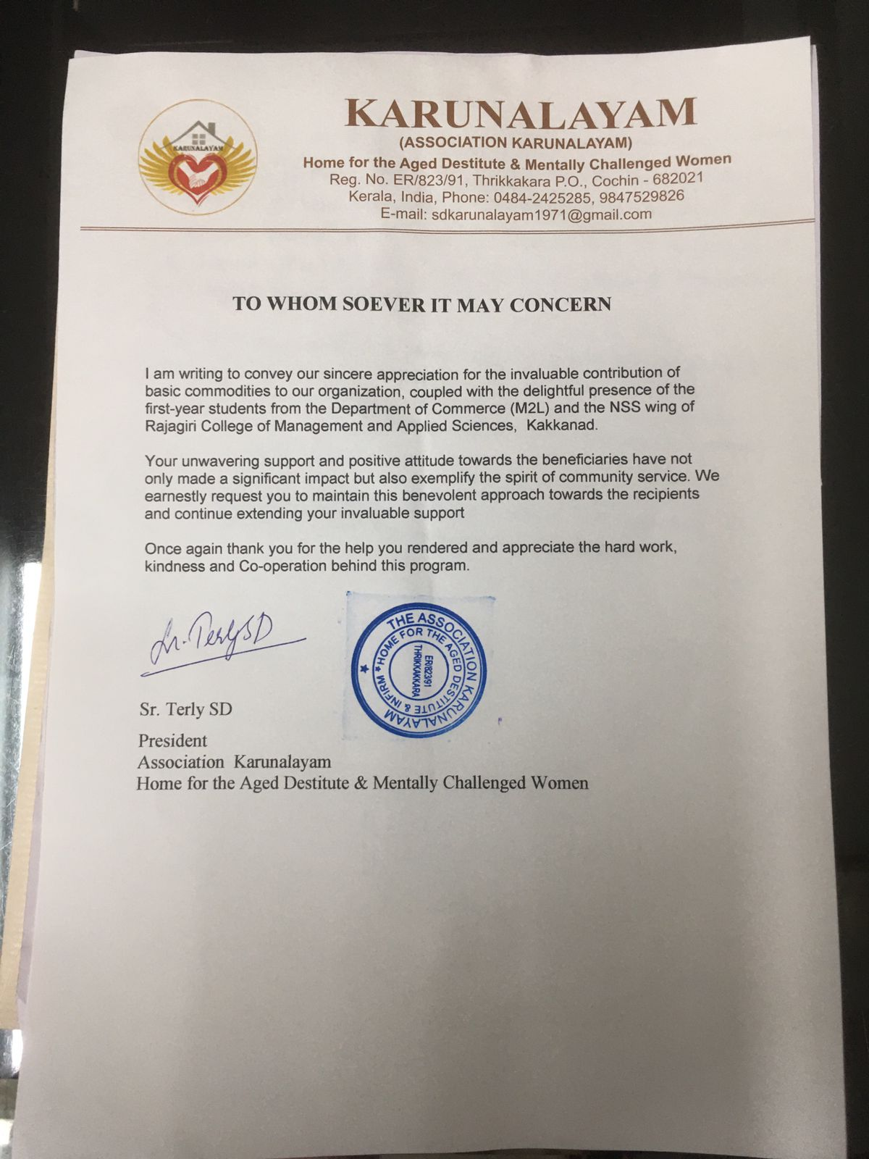

- Certificate of Appreciation from Thrikkakara Municipality

Name of Award | Certificate of Appreciation from Thrikkakara Municipality
Nature of Activity | Outreach activity through NSS to Community
Awarding Body | Councillor, Division 11, Thrikkakara Municipality, Kakkanad, Kochi 682030
Year of Award | 2023

Certificate of Appreciation
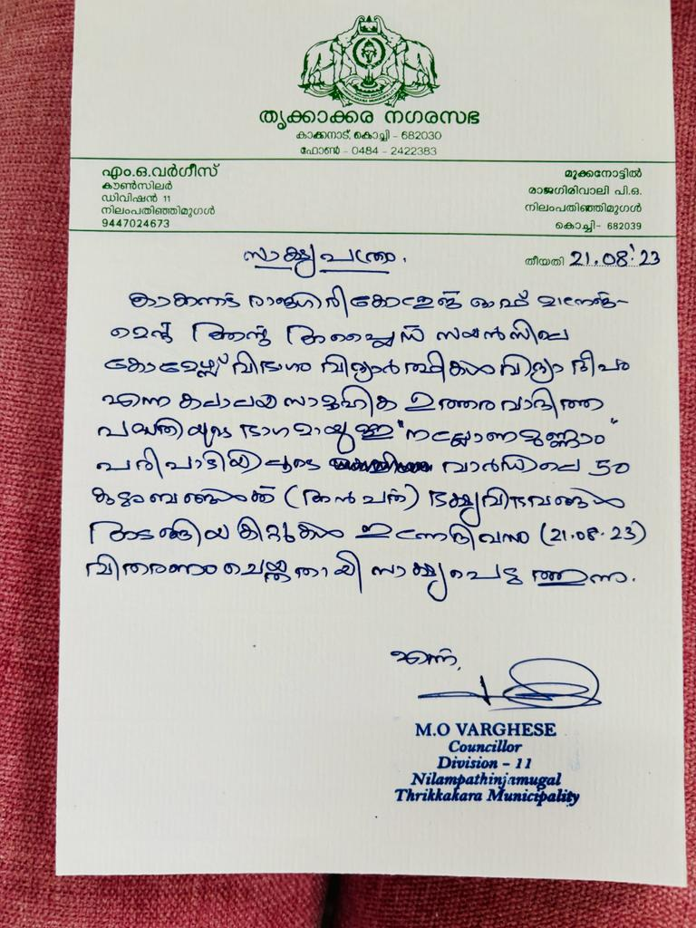

- Certificate of Appreciation from Thiruvaniyoor Grama Panchayat

Name of Award | Certificate of Appreciation from, Thiruvaniyoor Grama Panchayat
Nature of Activity | Free medical camp organized by NSS
Awarding Body | Thiruvaniyoor Grama Panchayat, Mamala PO, Ernakulam 682305
Year of Award | 2023

Certificate of Appreciation
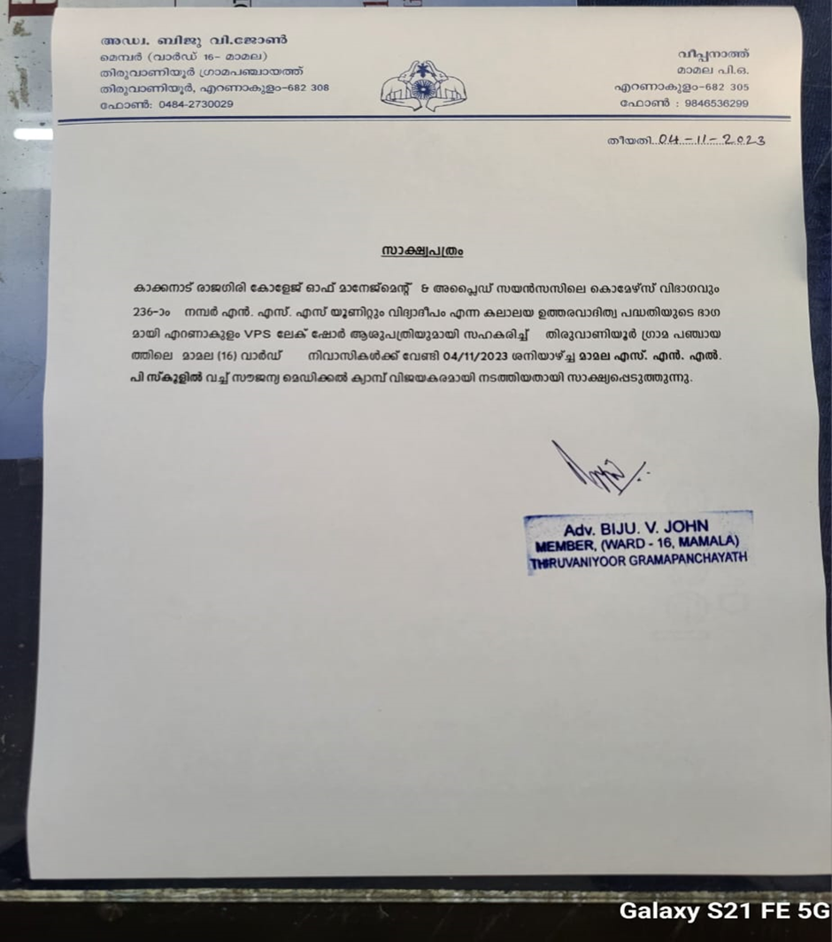

22. Certificate of Appreciation from the District Collector, Ernakulam

Name of Award | Certificate of Appreciation from the District Collector, Ernakulam
Nature of Activity | Outreach activity through NSS to Community
Awarding Body | District Collector, Ernakulam, Government of Kerala
Year of Award | 2023

Certificate of Appreciation
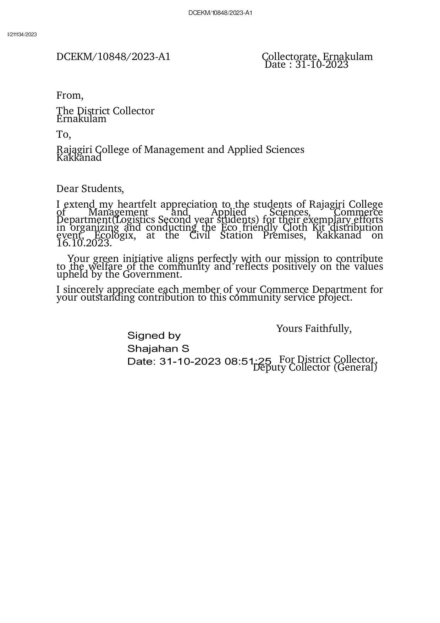

- Certificate of Appreciation from KSRTC

Name of Award | Certificate of Appreciation from KSRTC
Nature of Activity | Promoting public transport system
Awarding Body | Kerala State Transport Corporation (KSRTC), Aluva
Year of Award | 2023

Certificate of Appreciation

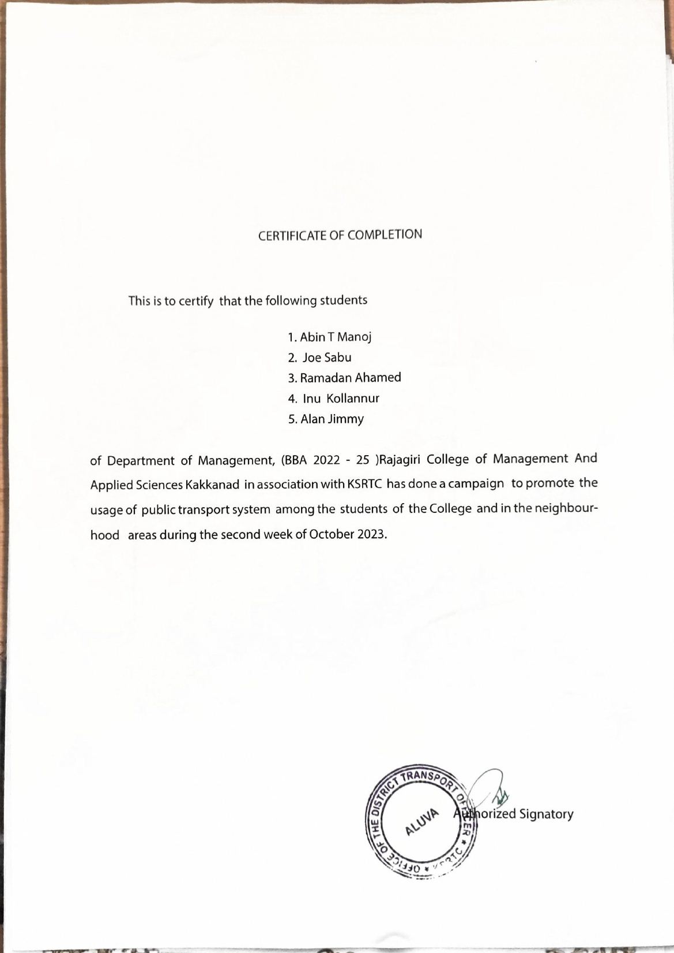

- Letter of Appreciation from Sevagram
Name of Award | Letter of Appreciation from Sevagram
Nature of Activity | Outreach activity through NSS to Community
Awarding Body | Sevagram, Pothi, Thalayolaparambu P.O, Pin 686605
Year of Award | 2023

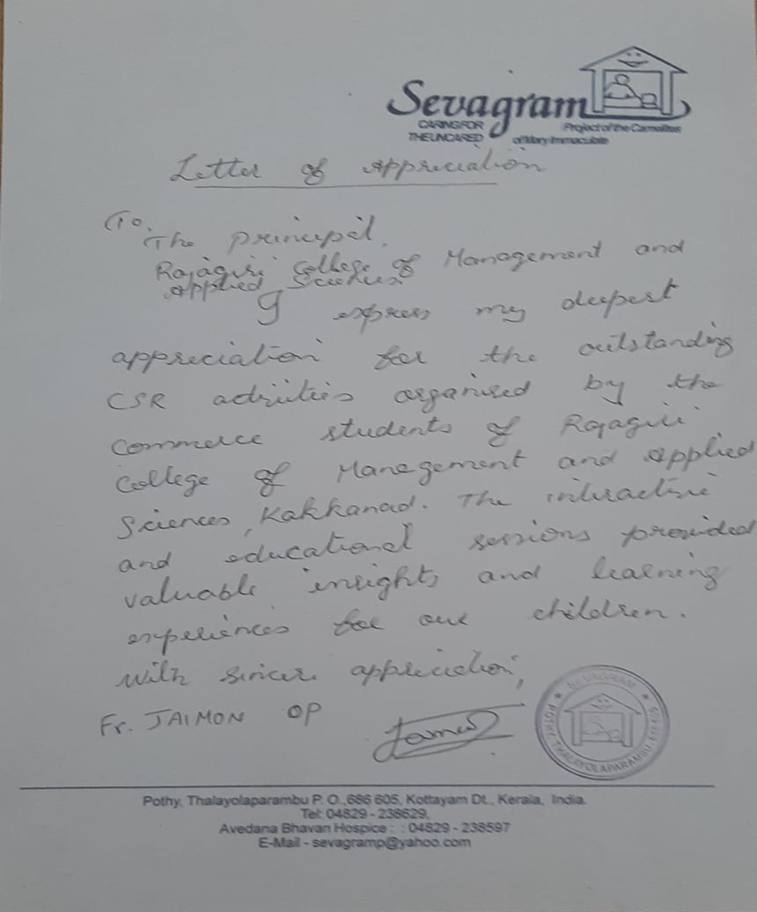
Letter of Appreciation

- Certificate of Appreciation from Indian Postal Service
Name of Award | Certificate of Appreciation from Indian Postal Service
Nature of Activity | Extension activity through NSS to Community
Awarding Body | Indian Postal Service, Rajagiri Valley 682039
Year of Award | 2023

Certificate of Appreciation

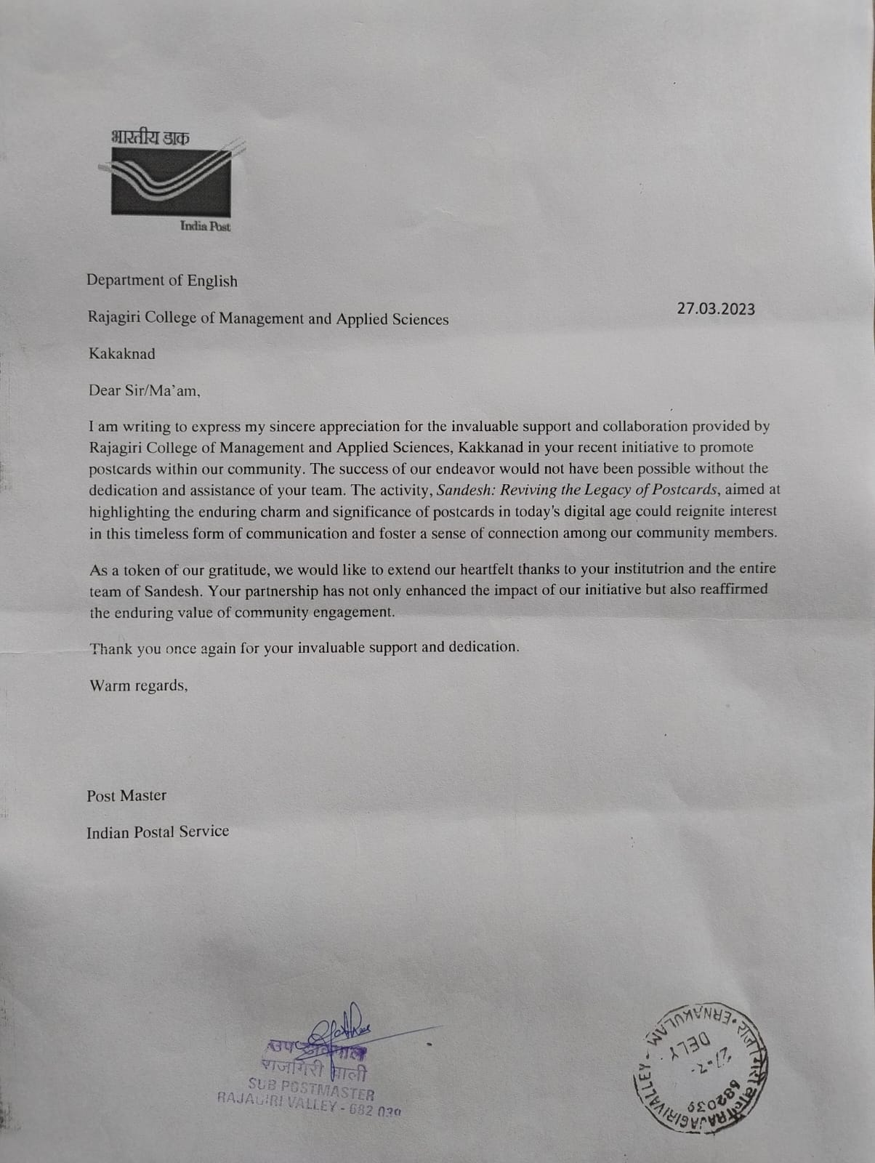

26. Letter of Appreciation from Home of Faith, Charitable Society

Name of Award | Letter of Appreciation from Home of Faith, Charitable Society
Nature of Activity | Extension activity through NSS to Community
Awarding Body | Home of Faith, Charitable Society, Chittethukara 682037
Year of Award | 2023

Letter of Appreciation
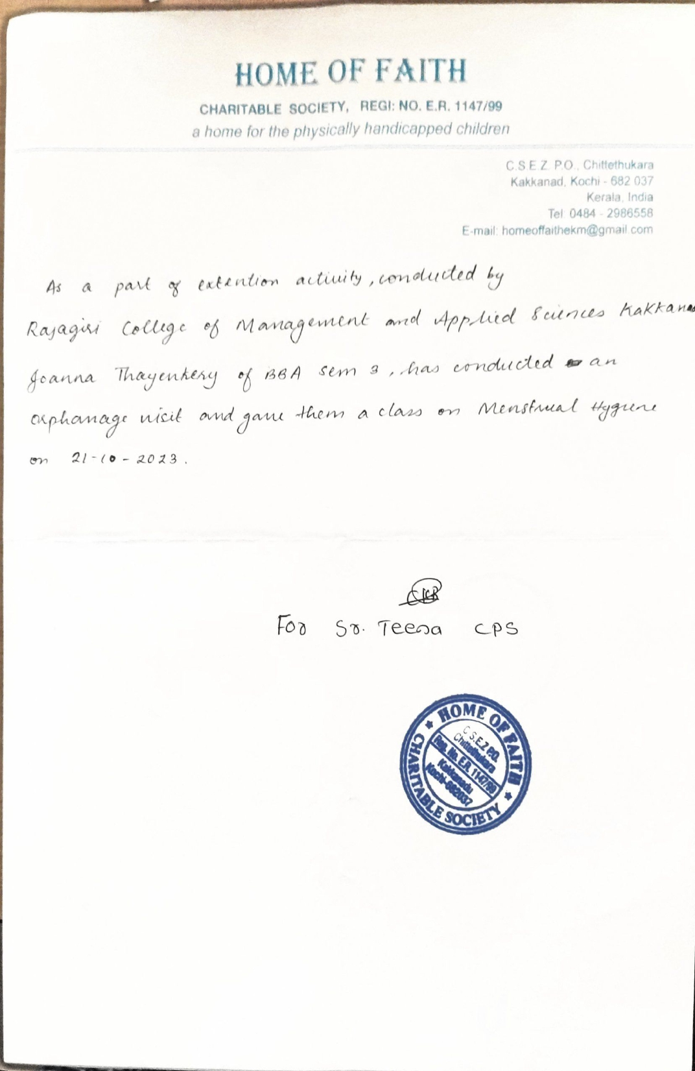

- Certificate of Appreciation from Motor Vehicle Department

Name of Award | Certificate of Appreciation from Motor Vehicle Department (MVD)
Nature of Activity | Awareness about traffic rules
Awarding Body | Motor Vehicle Department (MVD), Regional Transport Office (RTO), Ernakulam
Year of Award | 2023

Certificate of Appreciation
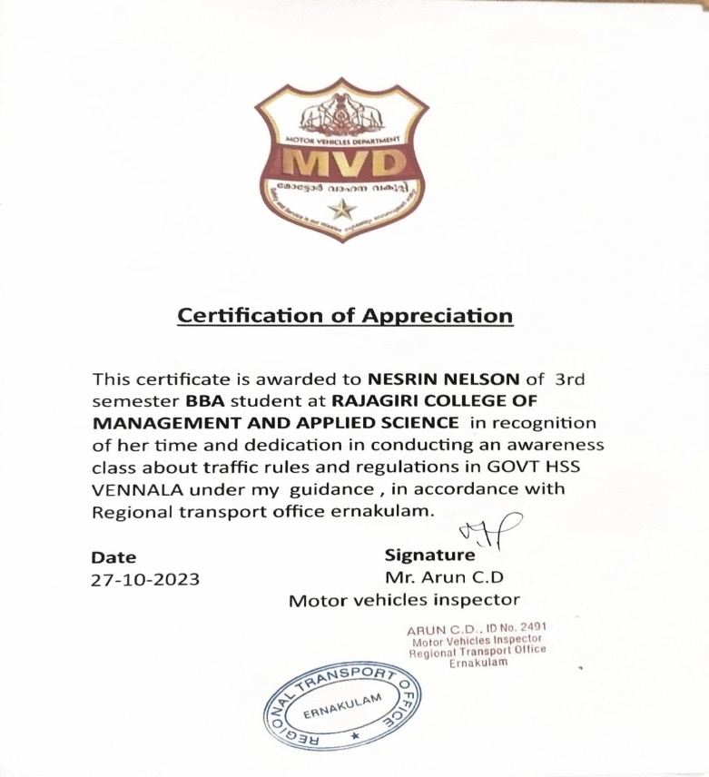
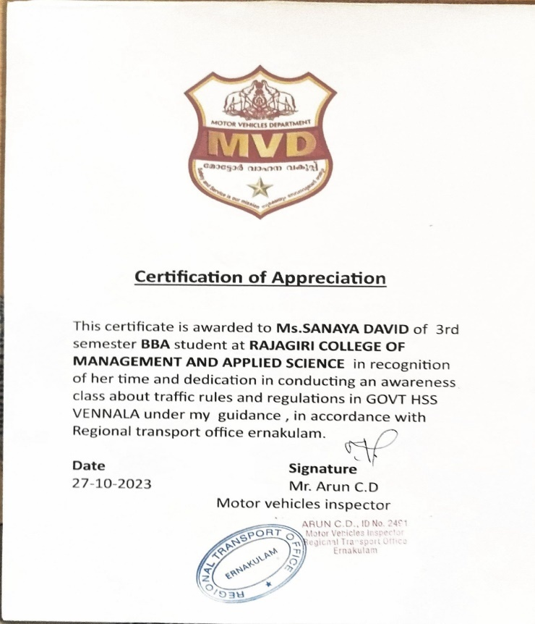

- Certificate of Appreciation from Health Department

Name of Award | Certificate of Appreciation from Health Department
Nature of Activity | Book donation to Anganwadi students
Awarding Body | Health Standing Committee Chairman, Division 14, Mavelipuram,Cochin 682030
Year of Award | 2023

Certificate of Appreciation
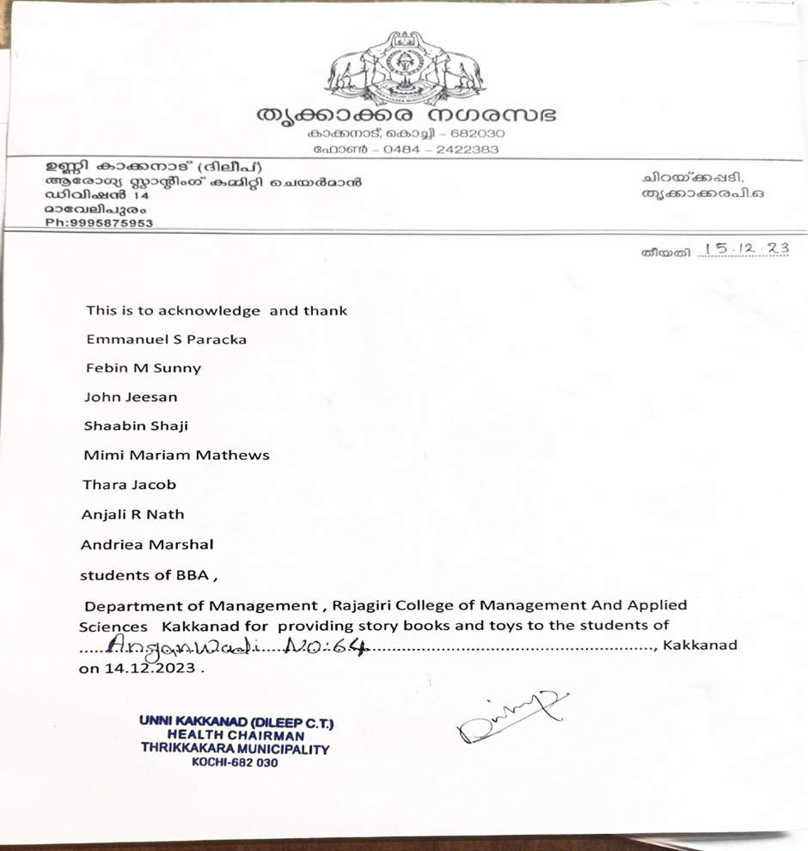

- Letter of Appreciation from St. Mary’s Higher Secondary School

Name of Award | Letter of Appreciation from St. Mary’s Higher Secondary School
Nature of Activity | Extension activity through NSS
Awarding Body | St. Mary’s Higher Secondary School, Thalacode P.O, Mulanthuruthy 682314
Year of Award | 2023

Letter of Appreciation

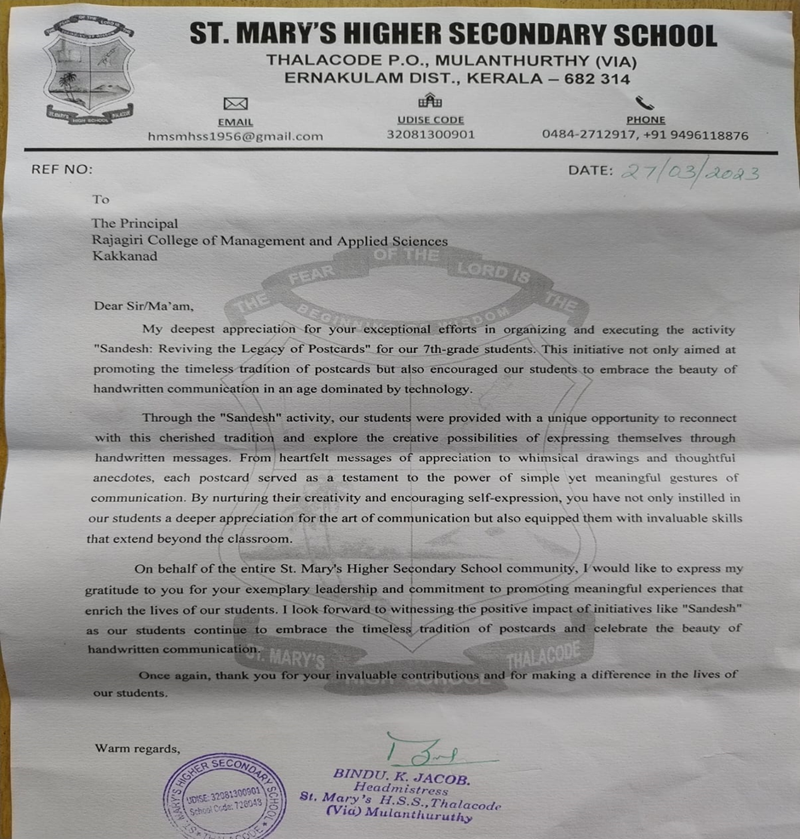

- Certificate of Appreciation from Government Children’s Home

Name of Award | Certificate of Appreciation from Government Children’s Home
Nature of Activity | Outreach activity through NSS to Community
Awarding Body | Government Children’s Home, Ernakulam 682030
Year of Award | 2023

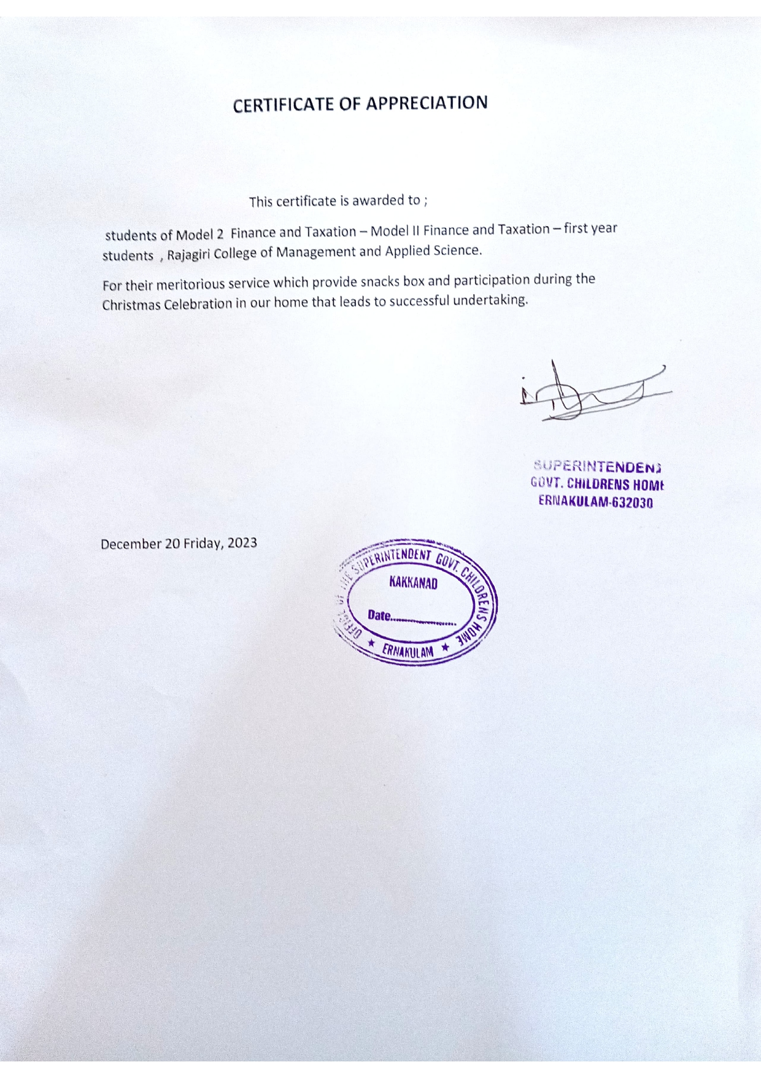
Certificate of Appreciation

- Letter of Appreciation from Lower Primary School

Name of Award | Letter of Appreciation from Lower Primary School
Nature of Activity | Extension activity through NSS
Awarding Body | Lower Primary School, Irumpanam Post, Ernakulam 682309
Year of Award | 2023

Letter of Appreciation

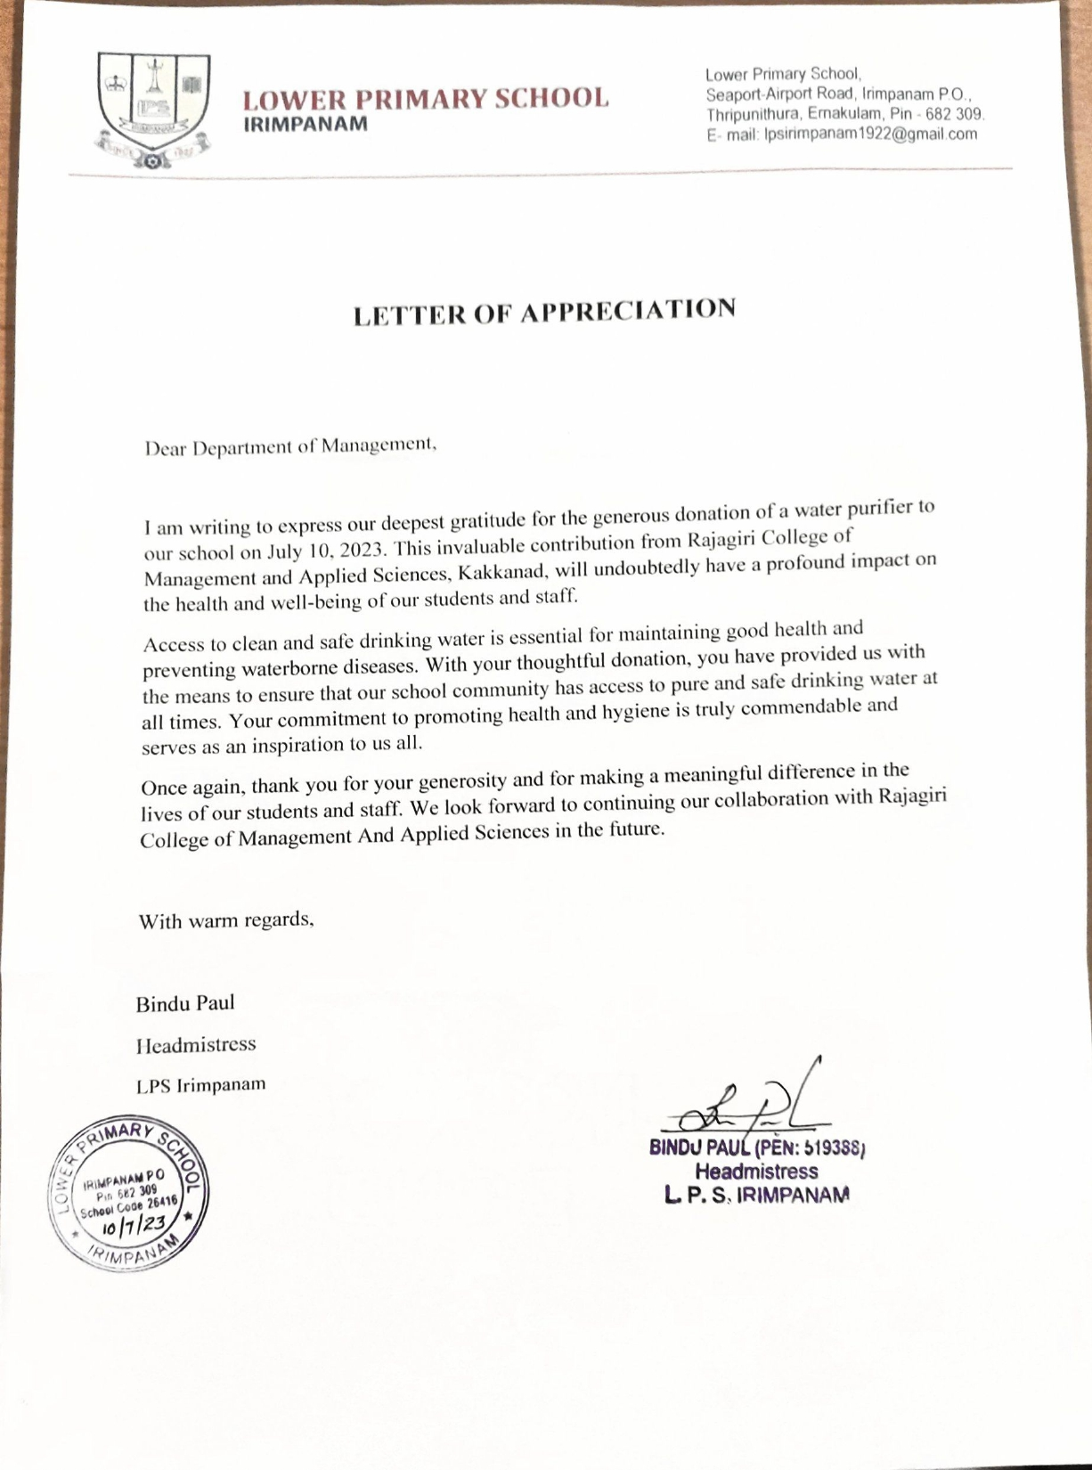

- Certificate of Appreciation from Kunji Store, IEDC

Name of Award | Certificate of Appreciation from Kunji Store, IEDC
Nature of Activity | Social initiatives
Awarding Body | Kunji Store, IEDC
Year of Award | 2023

Certificate of Appreciation

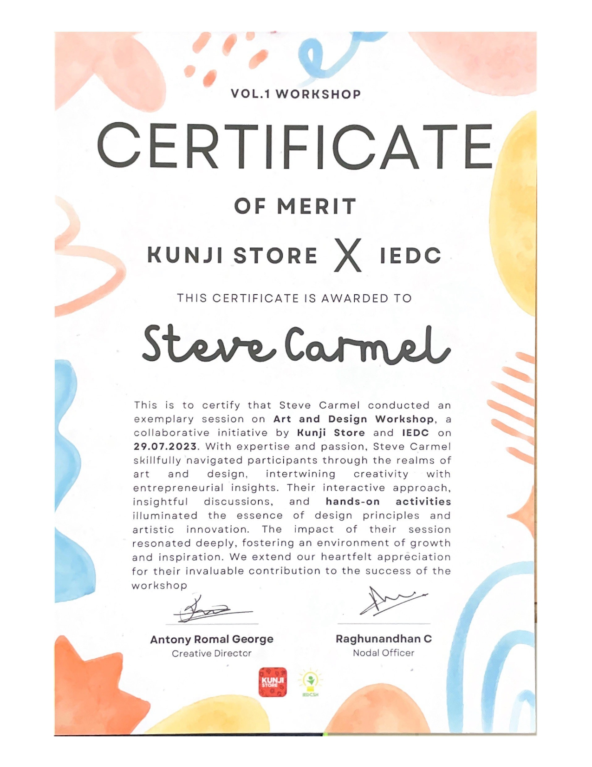

- Certificate of Appreciation from Popkon Creatives

Name of Award | Certificate of Appreciation from Popkon Creatives
Nature of Activity | Social initiatives
Awarding Body | Popkon Creatives, Mamangalam, Cochin 682025
Year of Award | 2023

Certificate of Appreciation

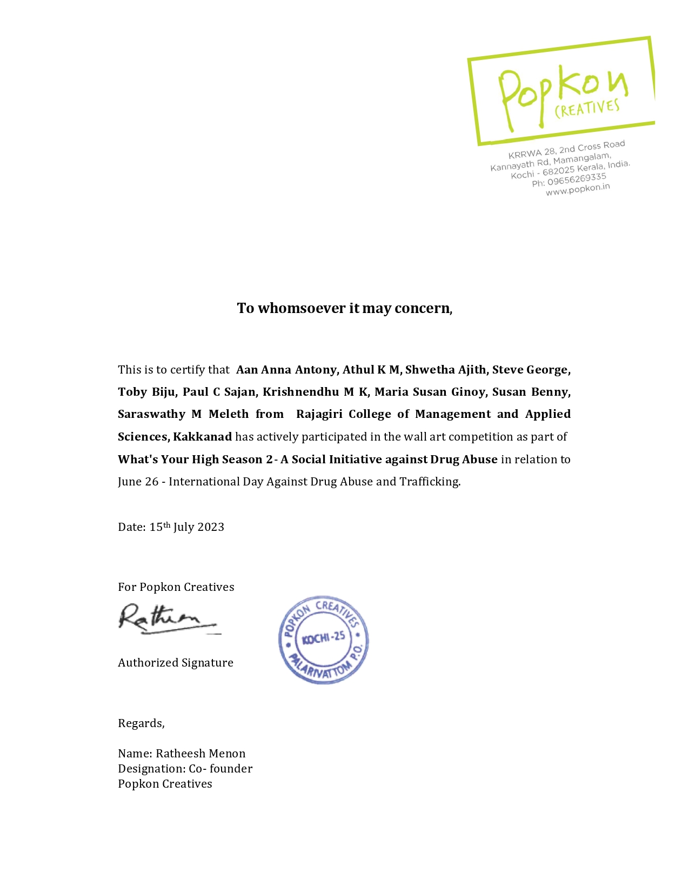

- Award from State NSS Office

Name of Award | Award from State NSS Office
Nature of Activity | Outreach activity of NSS
Awarding Body | State NSS Officer, State NSS Office, Government of Kerala
Year of Award | 2022-2023

Award Intimation Letter is attached

- Letter of Appreciation from Aided Lower Primary School

Name of Award | Letter of Appreciation from Aided Lower Primary School
Nature of Activity | Extension activity
Awarding Body | Aided Lower Primary School, Mulvukad 682504
Year of Award | 2022

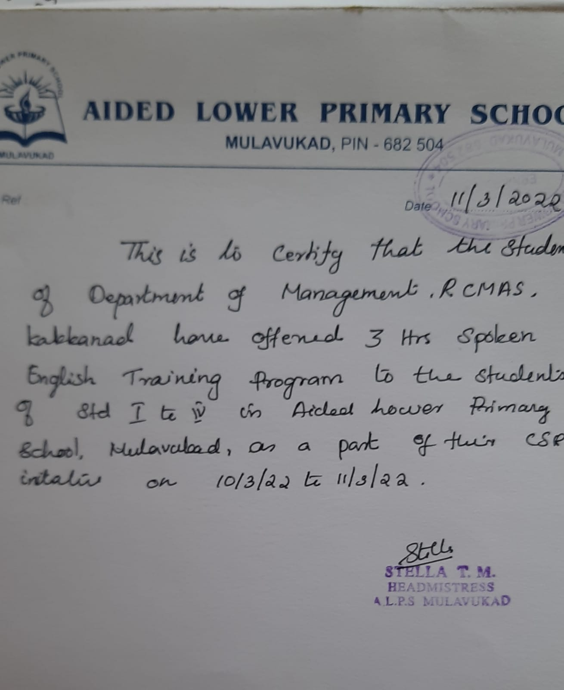
Letter of Appreciation
- Letter of Appreciation from St. Mary’s Higher Secondary School

Name of Award | Letter of Appreciation from St. Mary’s Higher Secondary School
Nature of Activity | Extension activity through NSS
Awarding Body | St. Mary’s Higher Secondary School, Thalacode P.O, Mulanthuruthy 682314
Year of Award | 2022

Letter of Appreciation

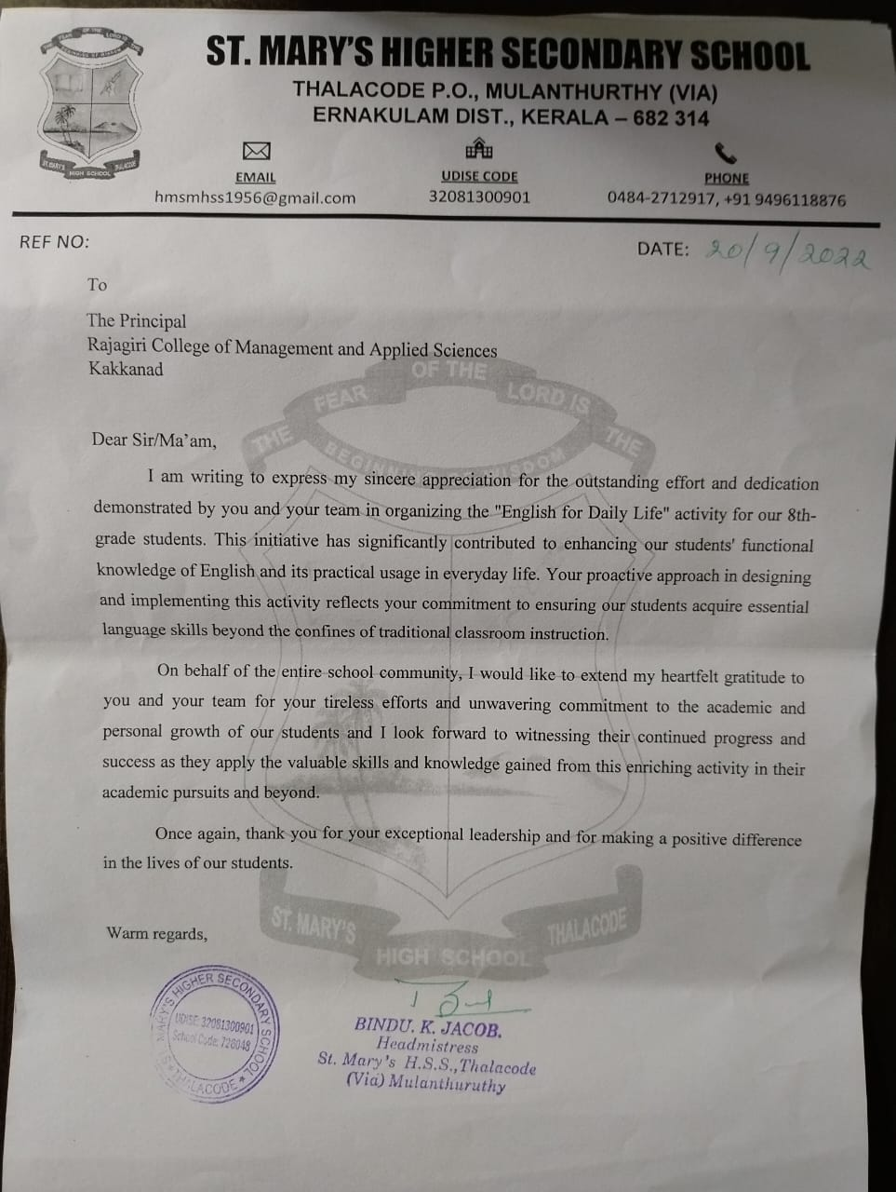

- Letter of Appreciation from Assisi Snehalaya Charitable Trust

Name of Award | Letter of Appreciation from Assisi Snehalaya Charitable Trust
Nature of Activity | Outreach activity through
Awarding Body | Assisi Snehalaya Charitable Trust, Coimbatore 641105
Year of Award | 2022

Letter of Appreciation

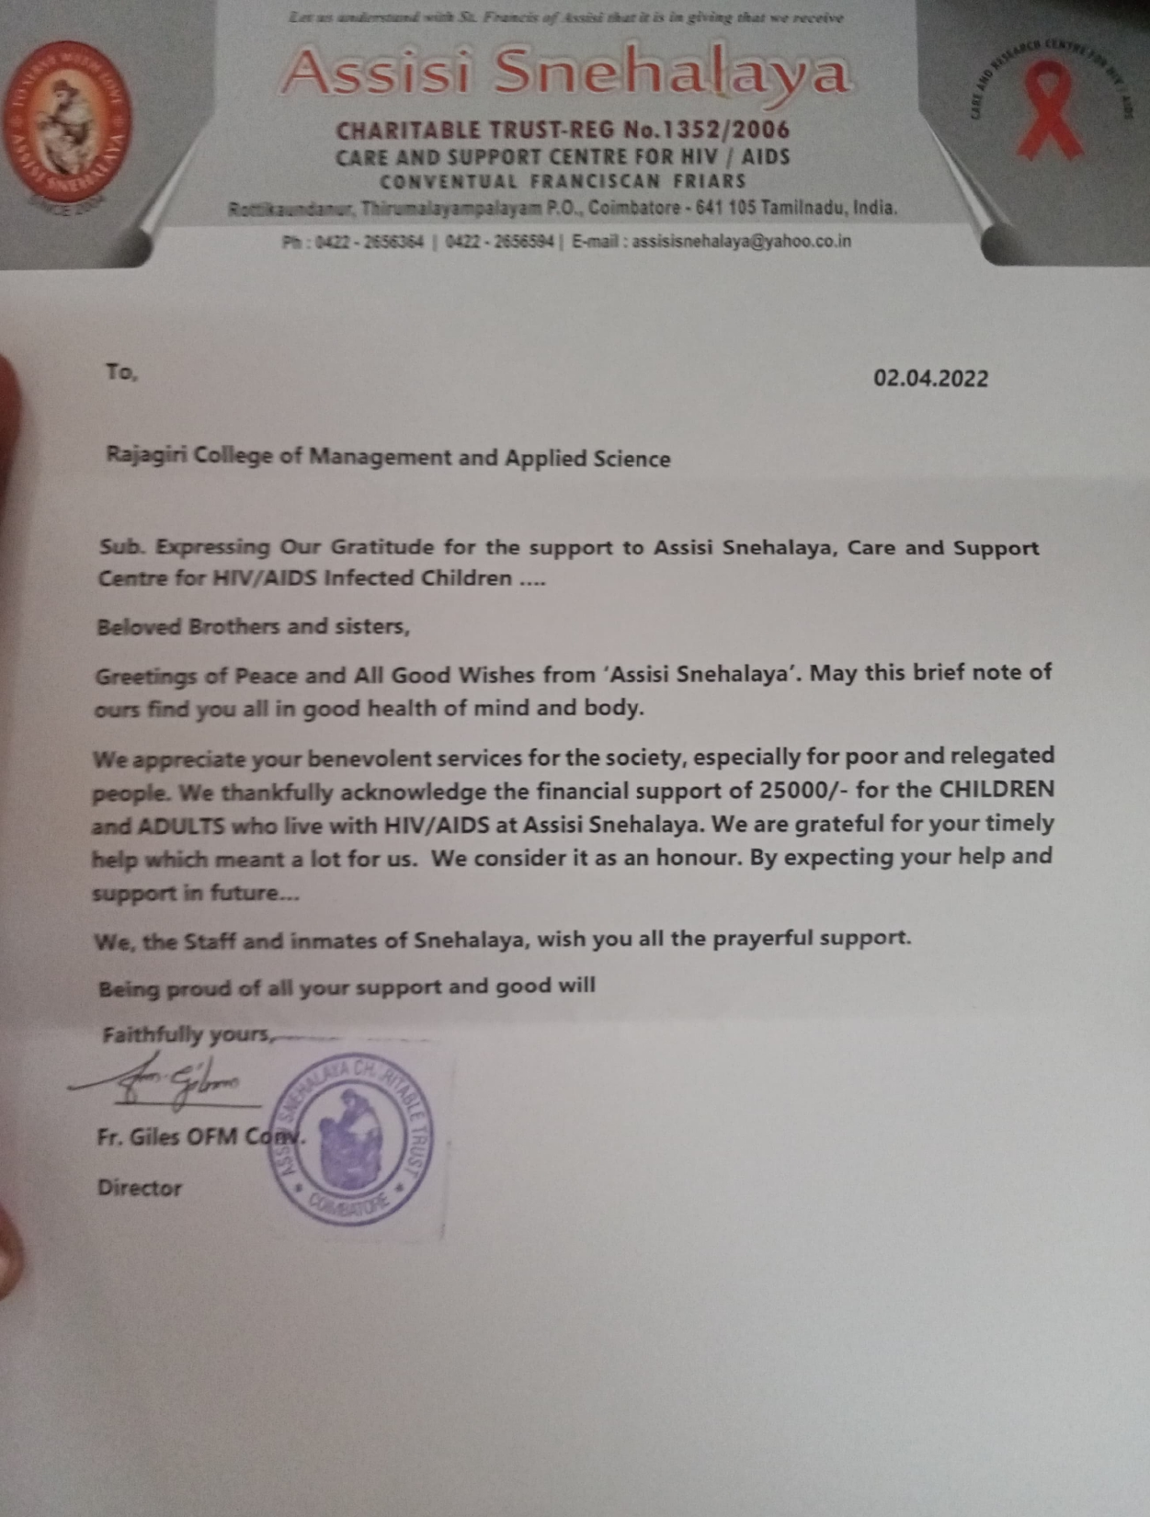
- Letter of Appreciation from Parama Bhattara Kendriya Vidyalayam

Name of Award | Letter of Appreciation from Parama Bhattara Kendriya Vidyalayam
Nature of Activity | Extension activity
Awarding Body | Principal, Parama Bhattara Kendriya Vidyalayam, Ernakulam 682038
Year of Award | 2022

Letter of Appreciation
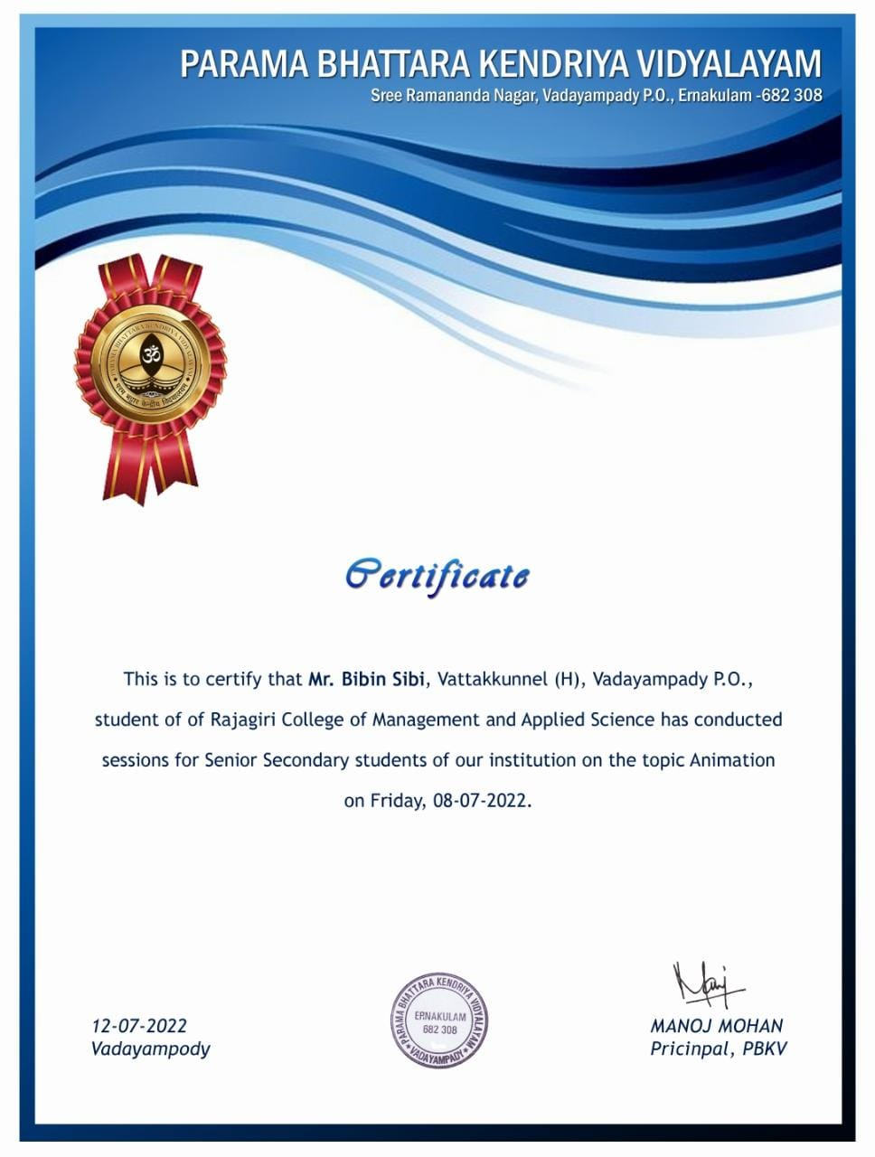

- Letter of Appreciation from D.V.U.P. School

Name of Award | Letter of Appreciation from D.V.U.P. School
Nature of Activity | Extension activity
Awarding Body | D.V.U.P School, Nayarambalam 682509
Year of Award | 2020

Letter of Appreciation

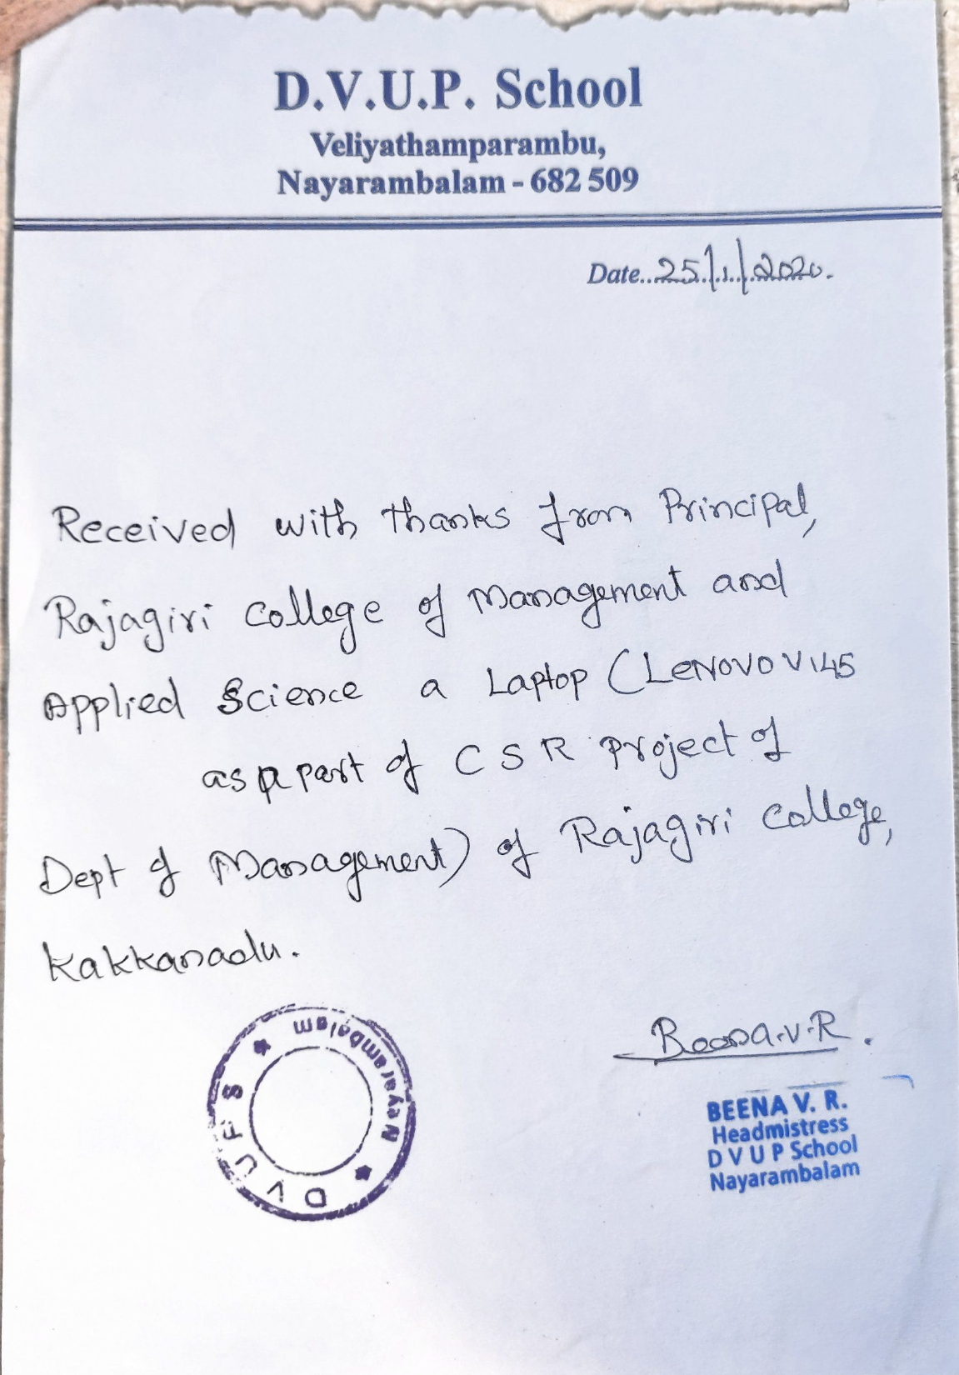
- Letter of Appreciation from St. Mary’s Higher Secondary School

Name of Award | Letter of Appreciation from St. Mary’s Higher Secondary School
Nature of Activity | Extension activity
Awarding Body | St. Mary’s Higher Secondary School, Thalacode P.O, Mulanthuruthy 682314
Year of Award | 2019

Letter of Appreciation

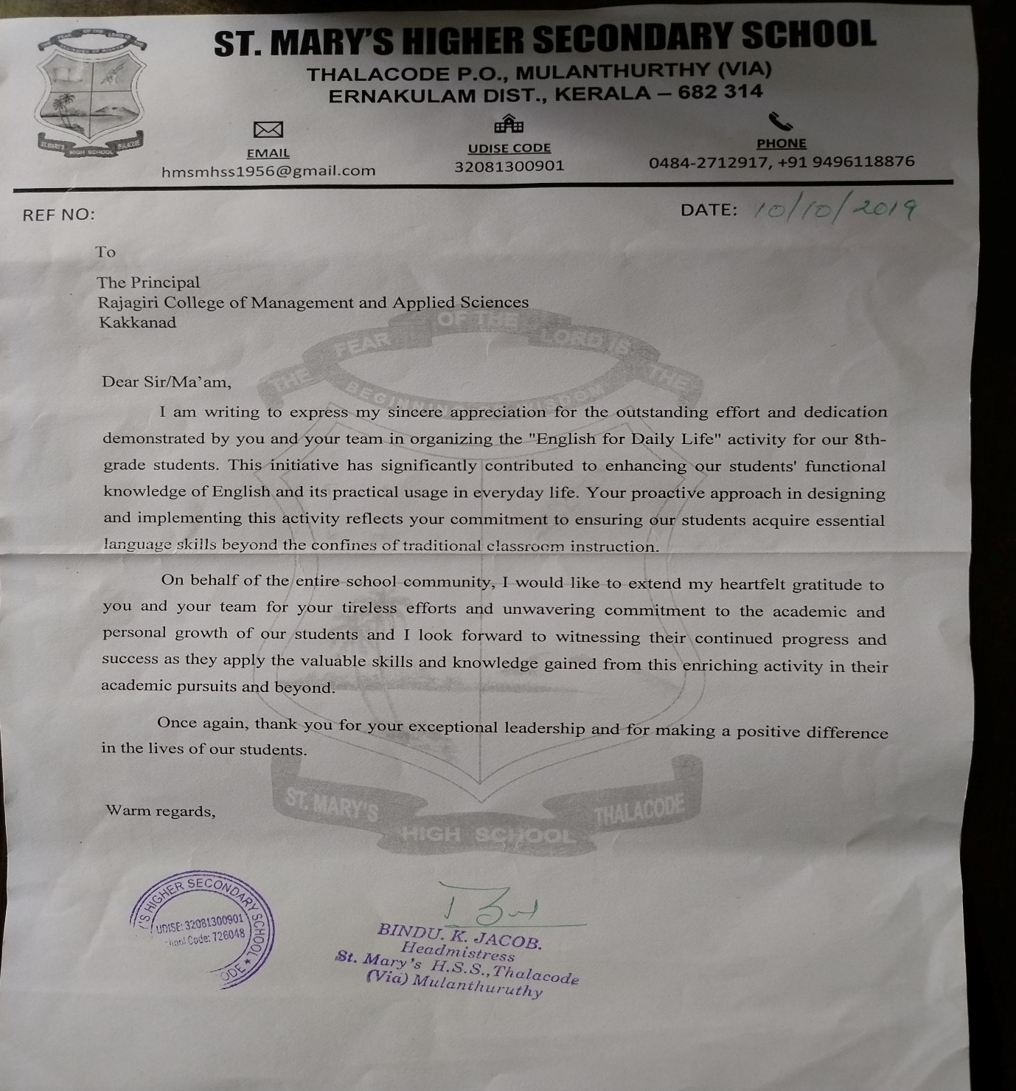
- Letter of Appreciation from Ernakulam District Administration

Name of Award | Letter of Appreciation from Ernakulam District Administration
Nature of Activity | Outreach activity
Awarding Body | District Collector, Ernakulam District, Government of Kerala
Year of Award | 2019

Letter of Appreciation

